What Happens to the Greedy Boy?
(Post-reading Activities)

Activity (a)
Materials: | Task Sheet 1
Picture Sheet
Sentence Sheet
some scissors
glue
Procedure:

- Teacher puts learners into groups of four.
- Teacher gives each group Task Sheet 1 and Picture Sheet.
- Learners cut the pictures and arrange them in correct order.
- Then they match the pictures with the sentences by writing the corresponding letters.
- Learners take turns to read the story to their groupmates.

Activity (b)
Materials: | a worksheet for each learner
 | Task Sheet 2 for each group
Procedure:

- Learners complete the worksheet to consolidate their understanding of the story.
- Teacher leads a class discussion on creating a different ending to the story. He/She gives a few examples to stimulate learners’ imagination on the development of the story.
e.g. ‘What do they do if there is a ring in one of the apples?’
‘What do they do if there is a tiger near the apples?’
- Teacher writes down learners’ ideas on the blackboard for their reference in the group task later.
- Teacher puts the learners into small groups and gives each group Task Sheet 2.
- Learners talk in their groups and put down a new story ending on their task sheets.
- Teacher encourages learners to use pictures to supplement their ideas as preferred.
- Teacher observes different needs and provides feedback during the discussion. Different groups share their work by reading their story endings out to the class.
- If preferred, Teacher collects the task sheets to provide feedback on story content or vocabulary for idea delivery.
- Teacher returns the task sheets to groups for their editing.
- Teacher provides groups with paper and stationery to make their own story books for displaying in the classroom.

1.  _________ | 2.  _________ | 3.  _________
4.  _________ | 5.  _________ | 6.  _________
7.  _________ | 8.  _________ | 9.  _________
Task Sheet 1
Class: P.3( ) Names:_____________________________________
Put the pictures in the right order. Put them in the boxes below.
Write the letters of the sentences on the spaces.

Cut the pictures. Put them in the boxes on Task Sheet 1.

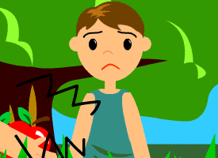 | 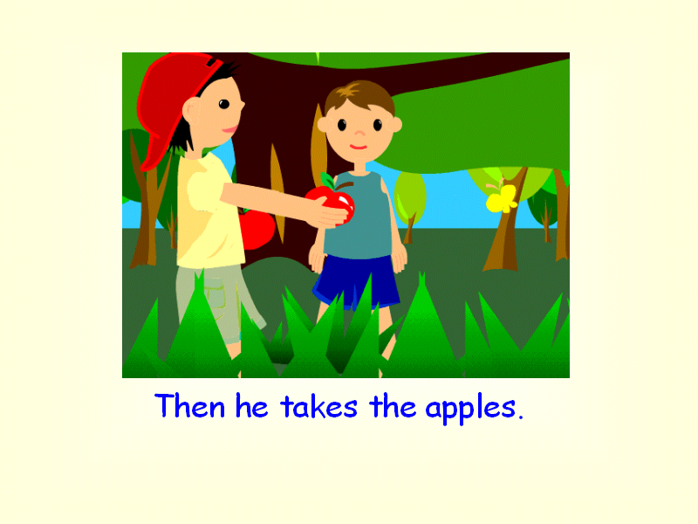 | 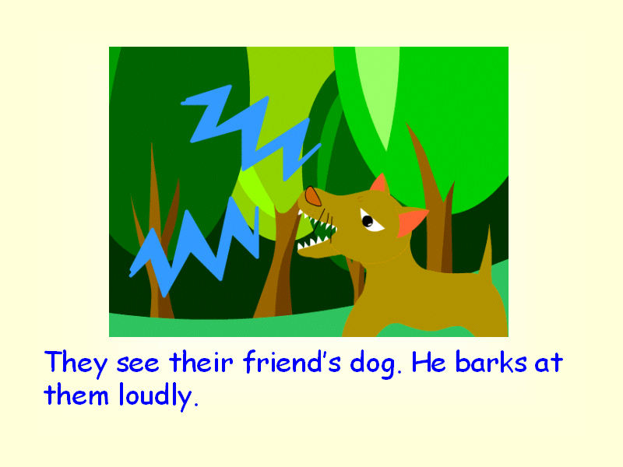
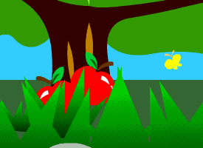 | 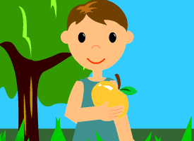 | 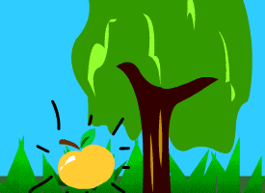
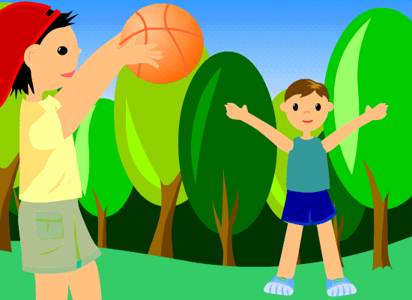 | 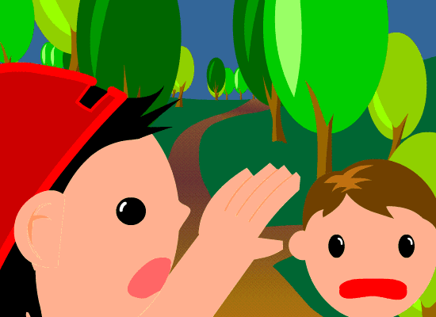 | 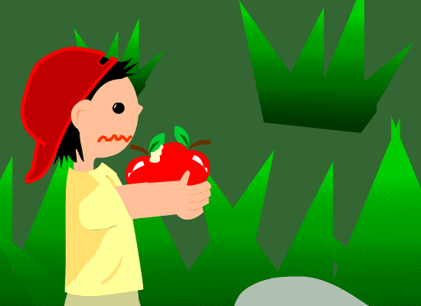

Write the letters of the sentences on the spaces of Task Sheet 1.

- Robert is greedy and takes both apples.
- Mark is hungry and sad.
- Mark is happy and eats the apple.
- They meet a dog. It barks at them loudly.
- Robert and Mark play in the wood.
- But Robert’s apples are bad. There are worms inside his apples.
- He sees another apple under a tree.
- They are afraid and run away.
- Then they find two apples under a tree.

Worksheet

Class: P.3( ) Name:_____________________________
Look at the pictures. Fill in the blanks below with the words in the boxes.
pears apples food tree bridge wood school
barks shouts happy afraid hungry
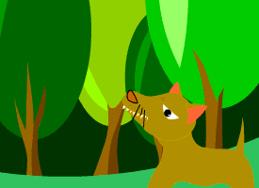
Robert and Mark are playing in a _________ .
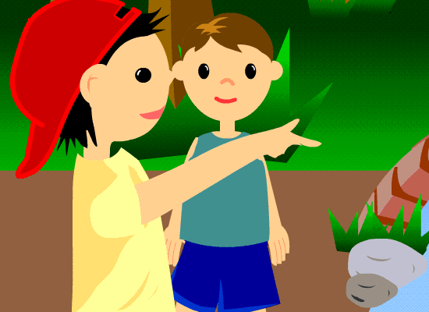
A dog __________ at them loudly.
They are __________ . They run away. They come
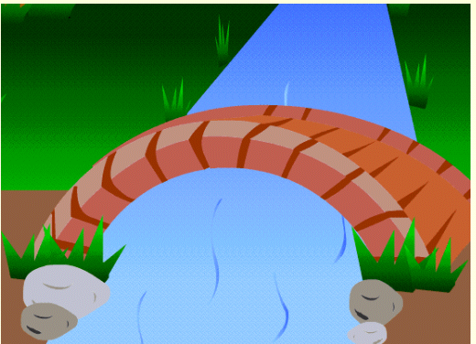
to a __________ over a river. They are
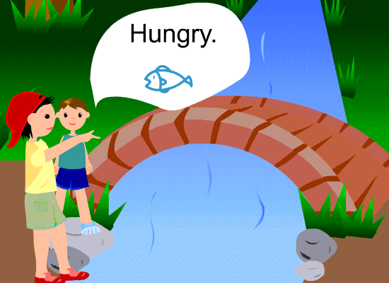
_________ and need some __________. There are no fish in the river.
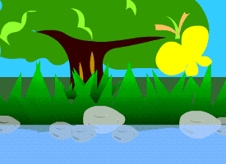
They see a ________ beside the river. There are
_________ under the tree.
Task Sheet 2
Class: P.3( ) Names:_____________________________________

Make the story ending fun!
Talk in your group.
Write at least 3 sentences to make your own story.

- Robert and Mark see the apples _______.  - _______________________________.  - _______________________________.  ________________________________.  ________________________________.  ________________________________.  ________________________________. | Pictures

