Making Tasty Food
(Pre-listening task I)
Materials: a set of jigsaw pieces

Procedure: | - Learners in pairs are given a set of jigsaw pieces. They match the jigsaw pieces containing the combinations of ingredients with the dishes. They then predict the different types of food they will be cooking later on.
 | - Then they tell the class the dishes they have come up with by reading aloud e.g. ‘We make fruit tarts with fresh fruits.’ Teachers provide support if learners encounter difficulty in pronouncing the words.

A set of jigsaw pieces


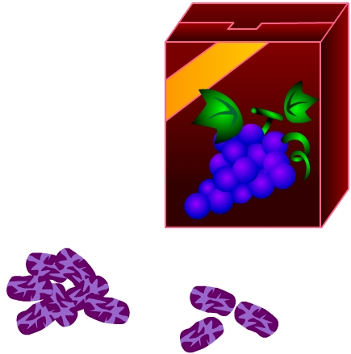
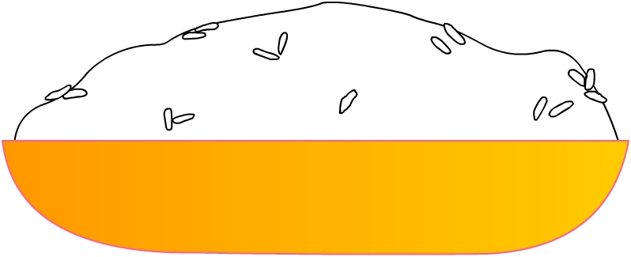
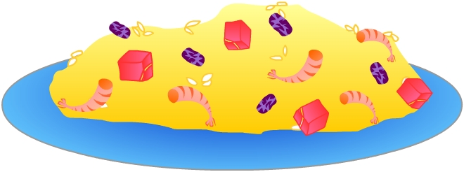
prawns
raisins

Fried rice
meat
rice

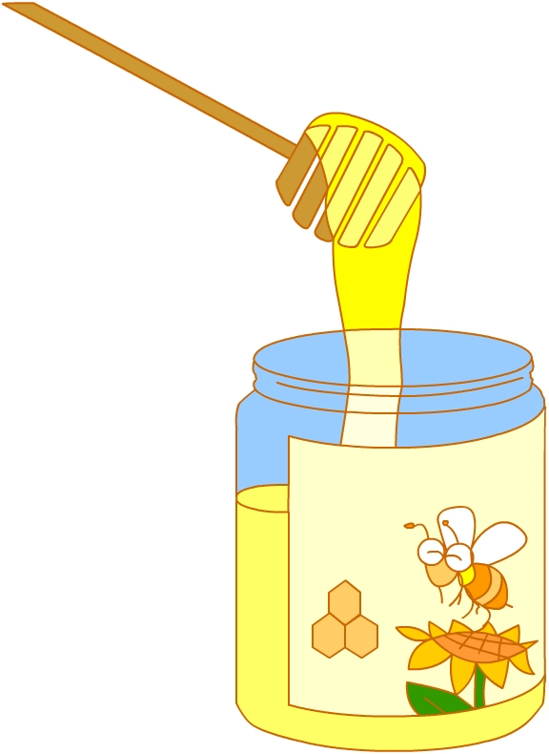

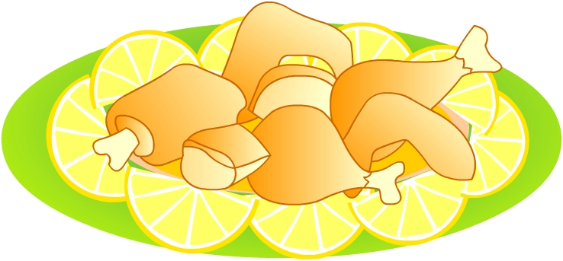
lemon

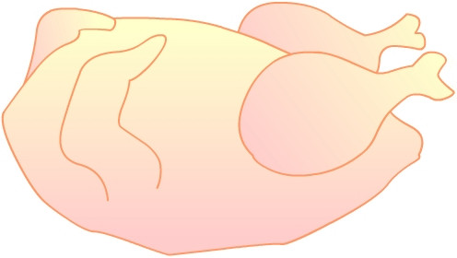
chicken
honey

Honey lemon chicken

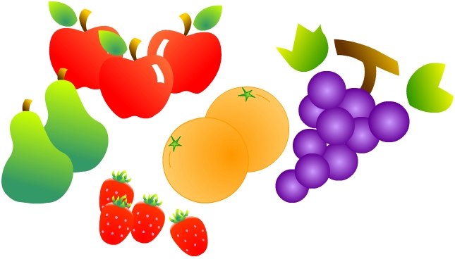
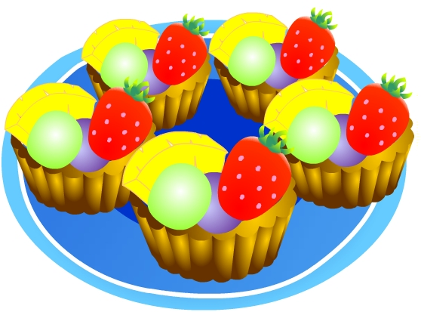
fresh fruits

Fruit tarts




spring onion
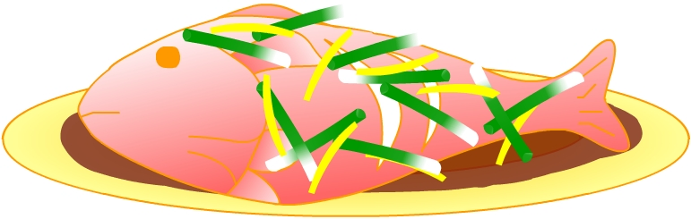
ginger

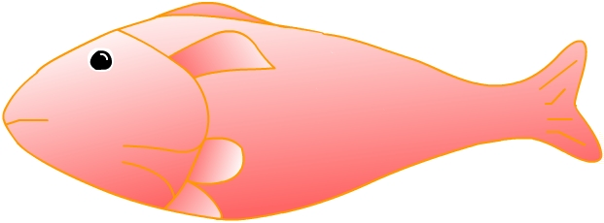

Steamed fish
soy bean sauce
fish

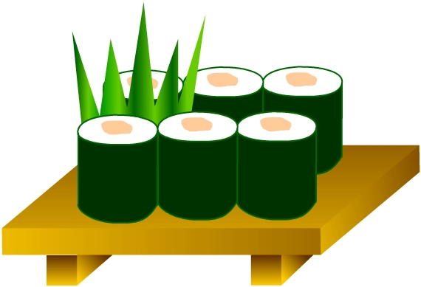
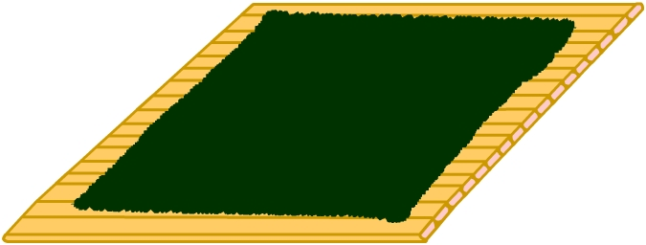
seaweed
rice
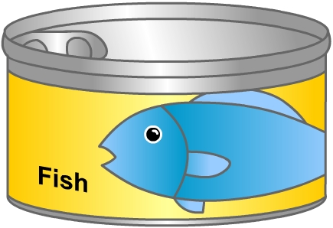

Sushi
Tuna fish

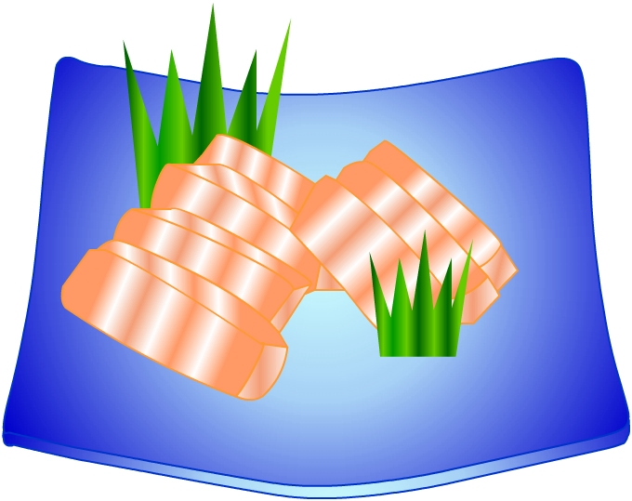


Sashimi
salmon


