Part 3: Designing a slogan

You are asked to design a slogan to promote one must-go spot in Hong Kong for the Hong Kong Tourism Board. You can use your own photos or you can draw the pictures for the spot you would like to promote. A sample has been given to you:
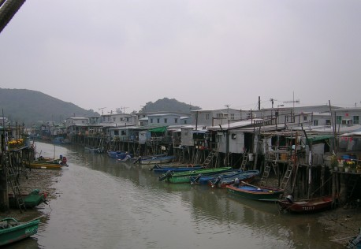
Come and unfold the silence
in Tai O Fishing Village!

I

Now, it is your turn to show your creativity to promote Hong Kong. You may refer to the following websites for further reference:

Welcome to DiscoverHongKong
http://www.discoverhongkong.com/

Hong Kong Fun in 18 Districts
http://www.gohk.gov.hk/

How to write a slogan

- Look at this photo of Tai O. Try to find out as many special features in it as possible.

Hints:
1. Where are the houses?
2. Are there any names for such special houses?
3. What and how does the place look like (a famous city) ?
4. How is living here different from city life?
5. Can you imagine the life in this place? (simple, free life)
6. Can you provide at least three adjectives to describe this place?
7. Are there any other special features that you can see from the photos?

Special features

Venice in HK – a village with houses built above water

Romantic life - for city people

no cars, only boats
so quiet and peaceful

2. Three sentences to describe special features in this photo:

Houses are built above water - like Venice.

Living in houses above water is romantic.

Tai O Village is quiet and peaceful.

3. Structure of a slogan

i) A slogan invites, encourages people to do something. It contains:

Come and unfold the silence in Tai O Fishing Village!
action verb ( inviting ) special feature object (place to visit)

Action verbs and phrases to use to invite visitors to come to Tai O Village

Action Verbs to invite and encourage
enjoy; experience; visit; come to; join

Phrases to invite and encourage
have fun in
welcome to
have a look at;
see …..for yourself;
feast your eyes with (enjoy the beauty of)

ii) Include the special features in your slogan. The special features make
Tai O Village and living in it special and attractive.
Tai O Village is quiet.
Living in Tai O Village is peaceful.
Tai O Villagers live in peace.
Living in a house above water is romantic.

iii) Sentence patterns for writing slogans

- Use simple sentence to invite people to Tai O Village

Visit (the) quiet and peaceful Tai O Village.
Verb Adjective - Special feature Object

b. Use phrases to describe the special features. We can use noun and adjective phrases to describe the special features

Examples :

quietness and peace
quiet and peaceful
quiet and peaceful life
quiet and peaceful village
quiet and peaceful Tai O Village
quiet and peaceful life in Tai O Village

Venice in Hong Kong
special houses in Tai O Village
special houses above water in Tai O Village
beauty of life with no heavy traffic
beautiful life with no noisy traffic

Examples of slogan for Tai O Village

- Enjoy the quiet and peaceful life in Tai O Village.
Verb Adjective -- Special feature Object

- Experience the quiet and peaceful life of Tai O Village.
Verb Adjective -- Special feature Object

- Welcome to the romantic life in Venice in Hong Kong.
Verb Adjective -- Special feature Object

- Welcome to the romantic life in Tai O – Venice in Hong Kong.
Verb Adjective -- Special feature Object

- Come visit the beauty of Tai O Village.

- Experience the beauty of quietness and peace in Tai O Village.

- Unfold the silence yourself in Tai O Village.

- Venice in Hong Kong – See it for yourself

- See it for yourself – Venice in Hong Kong

IV. You may try to write some slogans for this photo of Exhibition Centre and Victoria Harbour.

a. What special features can you find in it ?

i. tall buildings (high-rise buildings; multi-storey buildings)
ii. Exhibition Centre (grand-looking, shell-like roof)
iii. night view of the city ( Hong Kong)
- lights
- ferry plying in the harbour

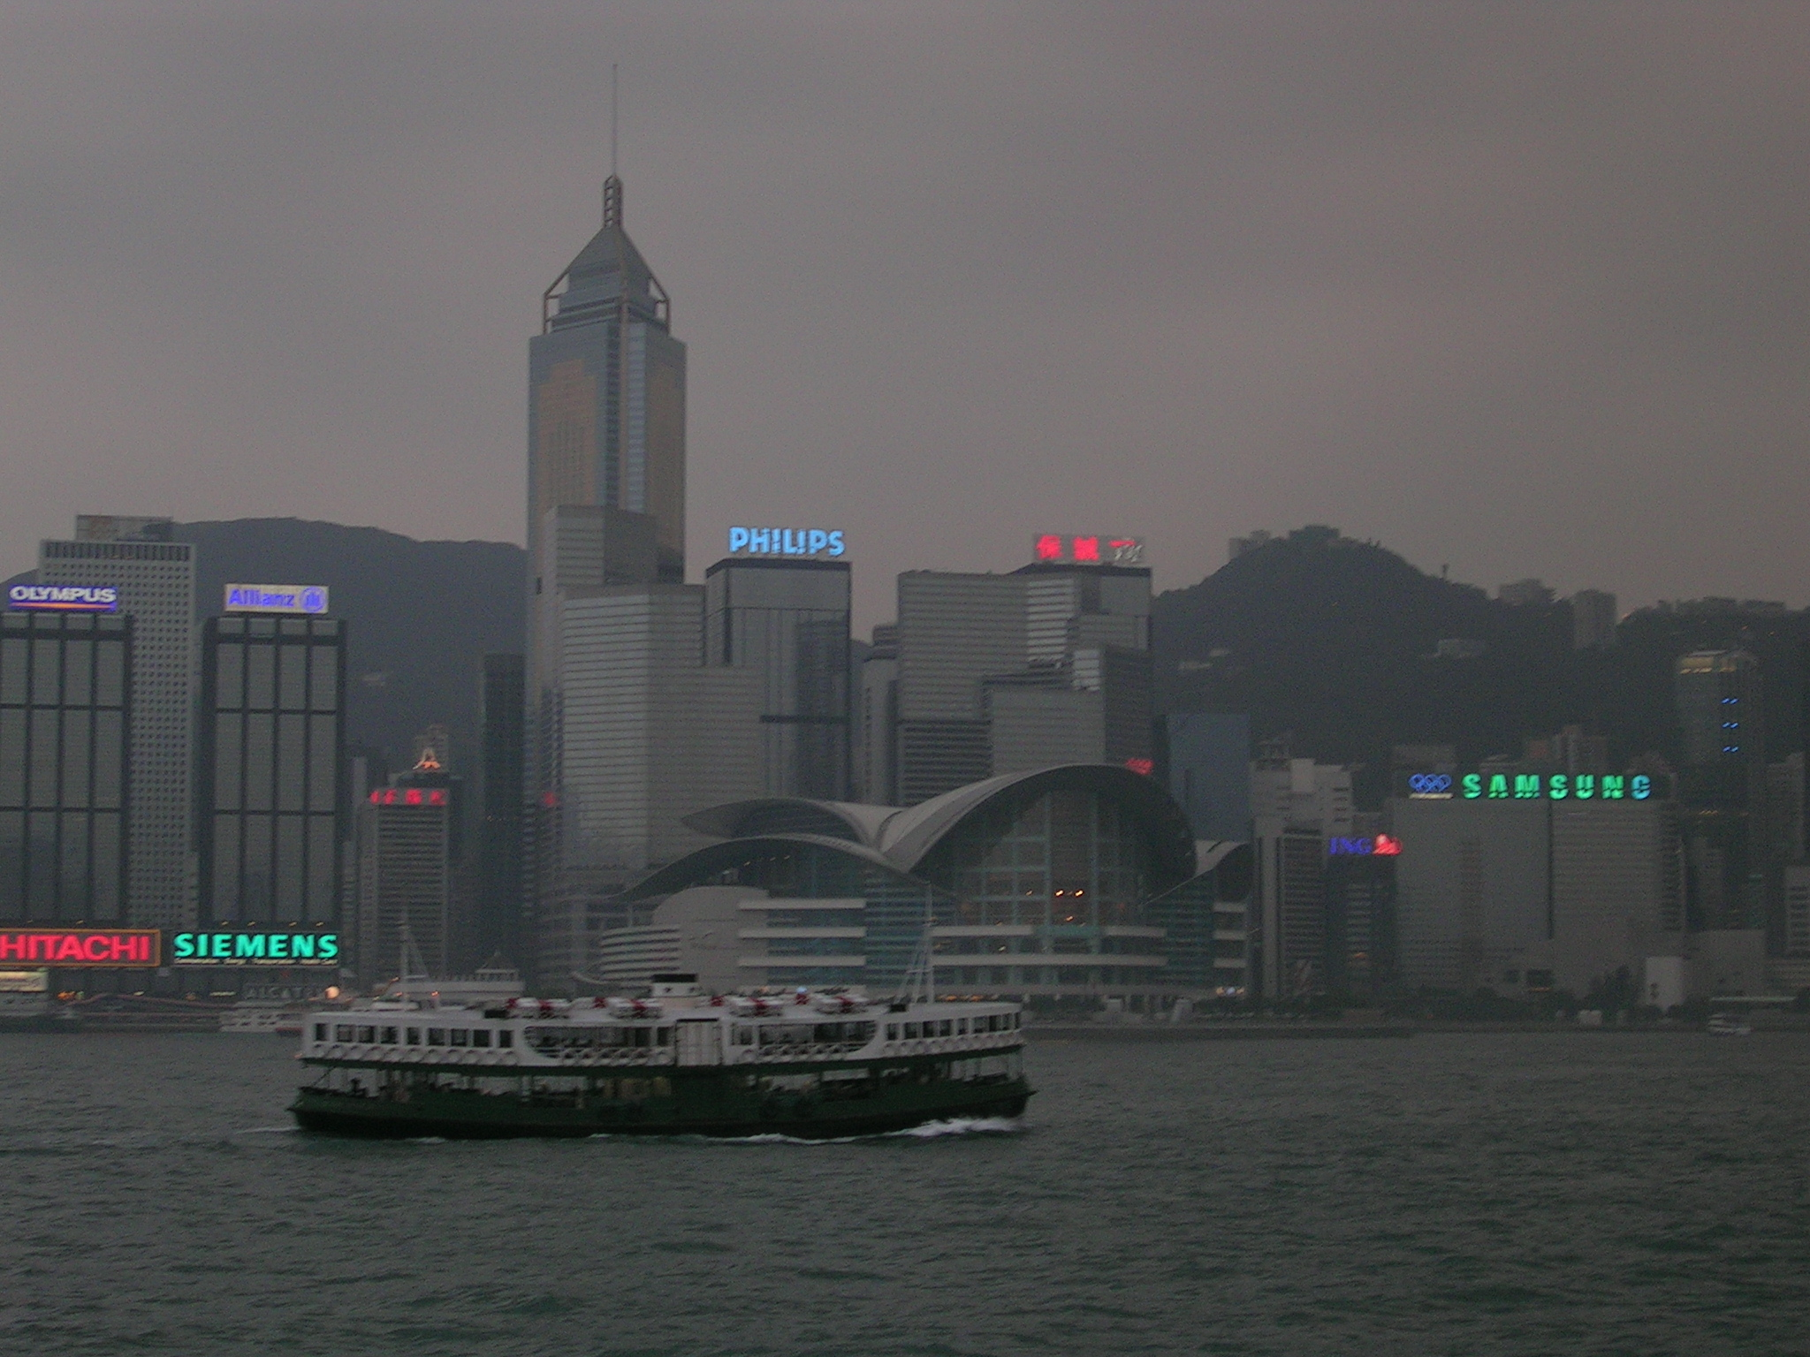

(iii) night view of city / harbour

(i) buildings

(ii) Exhibition Centre
(iv) lights

(v) ferry plying the harbour

b. Choose adjectives below to describe sentences i — v.

spectacular, grand, lofty, charming, fascinating, busy, colourful, modern, breathtaking, energetic

- The buildings are _______________.
There are ________________ buildings.
ii. The exhibition Centre is ______________.
iii. The night view of the city is _________________.
- The lights on buildings are _______________.
The lights of signs are ________________.
v. A _____________ ferry is plying in the Harbour.
c. Refer to the words and sentence patterns in A and write your slogans for this photo to invite visitors to enjoy the beautiful city of Hong Kong and Victoria Harbour.

For the night scene of the city
____________________________________________________________________
____________________________________________________________________
For the buildings
____________________________________________________________________
____________________________________________________________________
____________________________________________________________________
For the Exhibition Centre
____________________________________________________________________
____________________________________________________________________
For the lights on buildings
____________________________________________________________________
____________________________________________________________________
For the ferry plying the harbour
____________________________________________________________________
____________________________________________________________________

