Part Two Test on reading for main ideas

Passage A
Read the following story about Charlie Chaplin, the most popular comedian in America. Then choose the most suitable answers for the questions that follow.

Charlie Chaplin

Laughter should make people happy, not sad. Charlie Chaplin was a man who surely made millions of Americans happy in the early 1900’s. He greatly helped them face
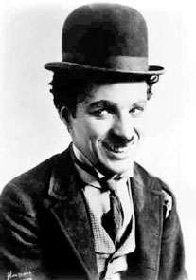
the two world wars and the Depression. He made them laugh for the first time and change the way they looked at the world and life in America when the economy was bad. Even though his films were in black and white, he put a lot of colour into everyone’s life. Charlie’s most famous films that many people loved were ‘The Kid’, and ‘Gold Rush’, etc. After these films Chaplin filled the sky as the most famous person in the world. In 1972, Chaplin was honoured at the Academy Awards as a wonderful comedian, actor and loving per son.

- Charlie Chaplin was popular in America, because
  - he was very happy.
  - his films made people laugh.
  - he helped people face two world wars and the Depression.
d. he showed people they could be happy.

- Charlie Chaplin was
a. a comedian.
b. a happy man.
c. a painter.
d. a film maker.

- All Charlie Chaplin’s films were
  - not in colour.
  - black or white in colour.
  - about the two world wars and the Depression.
  - about the life in America.

- Which of the following contains the key words in the passage ?
  - Charlie Chaplin; comedian; famous; laugh
  - comedian; film; world wars; Depression
  - Charlie Chaplin; famous; films; honoured
  - Charlie Chaplin; Americans; laugh; actor

Passage B
Read the following story about Henry Ford and fill in the blanks in the passage that summarizes the story.
Henry Ford
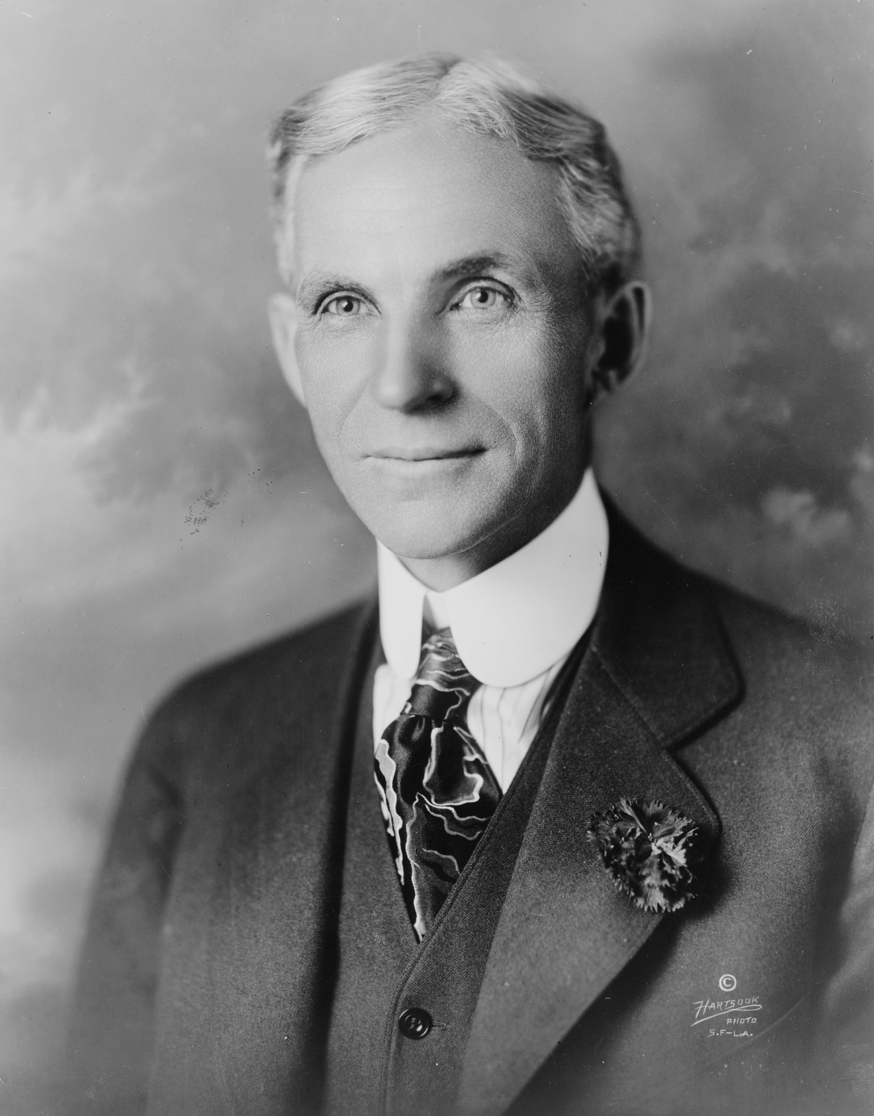
Henry Ford was born on a farm near the city of Detroit in the State of Michigan on July 30, 1863. He developed a great interest for machines when he was a boy. He was sure the
future of the automobile industry was
n a low-priced car for the general public,
so he made cars that anybody could
buy. His method in assembling cars cut
the time required from 14 hours to 1
hour 33 minutes. This method caused the
famous industrial revolution and Motor
Age that increased the income of millions
of Americans and shortened their work-
day. As a result they had more time to
enjoy life.

Born in ______________ in 1863, Henry Ford made _____________ cars for common people. His production ____________ greatly quickened the assembly of cars. This brought about the _______________________ that made Americans’ _________________ shorter and gave them __________ _________ to enjoy life.

Passage C
Read the following story about Henry Ford and fill in the blanks in the fact sheet about him.

Walt Disney

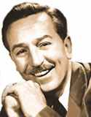
Walt Disney was the founder of Disneyland and Walt Disney World. Disney became interested in drawing at an early stage, selling his pictures to neighbours when he was only seven years old. In 1923, Disney’s brother and he started producing cartoons with $750. Success in cartoon production led to his
building the Disneyland in 1955. Within the first 30 years, more than 250 million people were entertained, including presidents, kings and queens from all over the world. His Walt Disney World in central Florida opened in 1982. It included a new amusement theme park, motel-hotel resort, vacation centre and his Experimental Prototype Community of Tomorrow. He was a legend and folk hero of the 20th century. His success was based on the idea which his name represents : imagination, optimism and self-made success in the American tradition.

Information about Walt Disney

Interest |  | Disneyland | Built in 19_________
First job | _____________  production | Disneyland | No of visitors up to 1985 : ____________
Work partner |  | Disney World | Opened in 19________
Investment | $ | Disney World | State it is in :_________

END

Suggested Answers

Passage A Charlie Chaplin

1. b
2. a
3. a
4. d.

Passage B Henry Ford

Born in ___Detroit___ in 1863, Henry Ford made ____low-priced____ cars for common people. His production _method_ greatly quickened the assembly of cars. This brought about the __ Motor Age_______ that made Americans’ __workday___ shorter and gave them time to enjoy life.

Passage C Walt Disney

Information about Walt Disney

Interest | drawing | Disneyland | Built in 19 55
First job | cartoon production | Disneyland | No of visitors up to 1985 : _250 million
Work partner | brother | Disney World | Opened in 19 82___
Investment | $ 750 | Disney World | State it is in : Florida_

