Guess Who!

Objectives: Students will be able to:
- understand the nature of adjectives
- describe people’s appearance with adjectives
- construct a sentence using more than one adjective
- understand the proper order of adjectives before a noun

Materials: A PowerPoint presentation—‘Guess Who!’
(Remarks: to use the ‘drag and drop’ function, please follow the instructions below to enable macros:
- Open PowerPoint
- Click Tools
- Click Options
- Click Security Tag
- Click Macro Security
- Select Medium
- Close and re-open PowerPoint
- Click Enable Macros if asked)

A pocket chart

If you do not use the presentation:
      - Adjective cards (including adjectives that describe appearance i.e. slim, pretty, etc)
      - Noun cards (objects and people)
      - Pictures cards (characters in the previous activity)
      - Some blank cards

Procedure:
- Activate/Assess prior knowledge on the concept of adjectives.
- Show students a picture of a celebrity (e.g. Andy Lau). Ask students: ‘What do you think about him?’
- Write down all the words students provided. (OR: use the drag and drop game in the PowerPoint presentation on screen or on interactive whiteboard) Circle all the adjectives and point out that these words are used to tell us more about things and people.

- Game Time: Who am I?
- After introducing the characters from the story and showing the examples in the presentation, the game begins. (For less able students, teacher can always show the slide with the character list as a hint.)
- Model first for students: One at a time, each student holds a picture card on their forehead (without looking at the answer on the card) and classmates describe the picture to the student holding the card, using descriptive sentences with adjectives.
- Provide a clue to start (i.e. the person is a man or a woman, etc.). The student holding the card tries to guess who the character is by listening closely to his classmates' guesses.
- Ask prompting questions if needed (i.e. Can you say more about his face? Can you say more about his clothes?).
- An example would be if the student is holding a card with the King, classmates may create sentences such as:
      - He is a sad old man.
      - He has short curly grey.
      - He is wearing a long purple robe.
(For less able students, teacher should accept simple sentence with one adjective in a sentence. For more able students, teacher can encourage them to produce sentences with more than one adjective despite the order of the adjective.)

- Order of Adjectives
Take out a picture card (the Princess card for example) and ask the students to use as many adjectives as they can to describe it.
- Princess Nancy is slim.
- She is beautiful.
Ask students to use only one sentence to describe her. What should they do?
Using the pocket chart, teacher can demonstrate different ways to arrange the order of the adjectives in a sentence.
Raise the question whether students should put the adjectives in particular order.
Another example for students:
- Her hair is long.
- Her hair is wavy.
- Her hair is brown.

- Show students a table on the board: (using the pocket chart again)
Feeling | Size | Age | Shape | Colour | Noun
beautiful | slim | young |  |  | lady
 | long |  | wavy | black | hair
 | big |  | round | brown | eyes
Invite students to describe the teacher. Teacher then writes down the adjectives on the table.
Tell students that if more than one adjective is put before a noun, you have to follow this order.
Ask a student to read out a sentence using the example of the teacher:
- Miss Law is a beautiful slim young lady.
Invite student to describe another student or a student’s appearance (e.g. eyes, hair, face, clothes and other belongings like schoolbags) to encourage more practice.
- She has long wavy black hair.
- She has big round brown eyes.

- Game: Guess Who!
Group work:
- Students in groups are assigned a name of their classmate by the teacher. Then they have to discuss what he/she looks like and write down the adjectives.
(Teacher can assign roles like a presenter for more able students in the groups)
- With reference to the order of adjectives as shown in the table, they have to make up 2 to 3 sentences about that classmate.
- Rules can be set up. Students, each in turn, describe (orally or written) the classmate with an adjective. Each group member needs to contribute at least one sentence about the person.
- Other groups have to make a guess of who the person is.
- Teacher debriefs the class by the end of the lesson, getting the students to share how well they worked and providing feedback.
Appendix 1
Pictures of the Characters
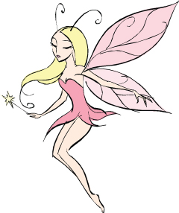 | 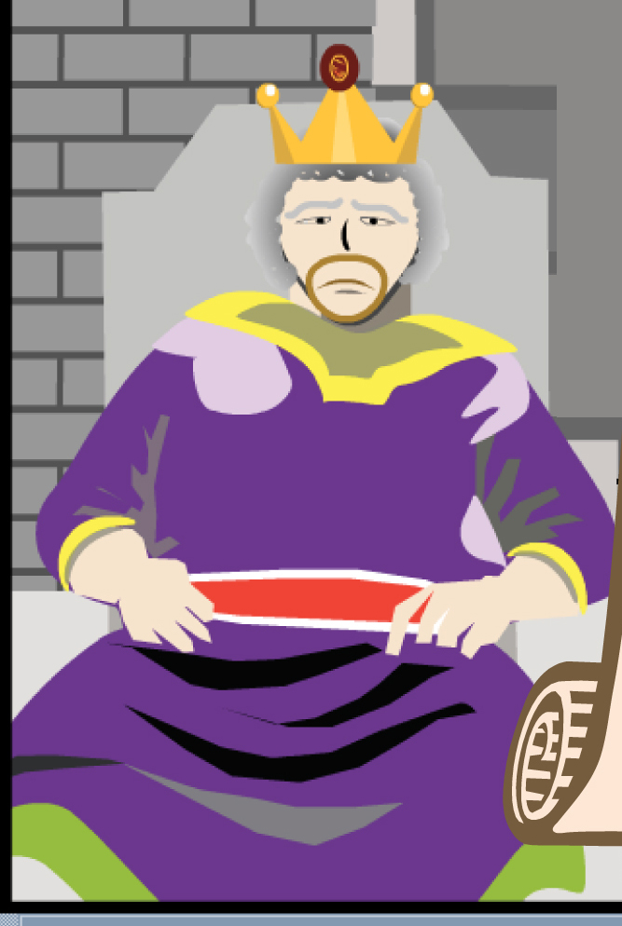
 | 
 | 

Appendix 2
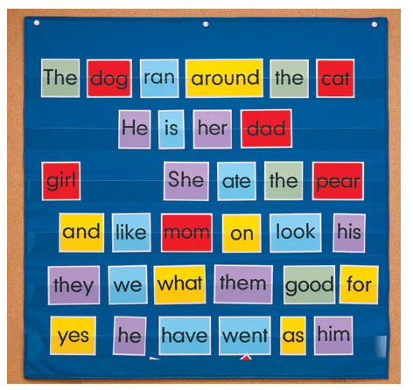
A pocket chart

