Reflectional Symmetry of the Cube

Key Stage | ： | 3
Dimension | ： | Measures, Shape and Space Dimension
Learning Unit | ： | More about 3-D Figures
Basic Competency | ： | KS3-MS8-1  Name planes of reflectional symmetries of cubes.
Introduction：
The teacher distributes the worksheet “Reflectional Symmetry of the Cube”.

Students use the PowerPoint file “Ref-Cube.pps” to complete the activities in the worksheet.
(Cabri 3D Ver 1.2.1 (or above) must be installed first. A free evaluation copy can be downloaded.)
In each activity, students see a mirror that divides the cube into two halves. Students drag the mirror to different positions, and observe at which positions the mirror image of one half of the cube would coincide with the other half. Through the activities students perceive the concepts of reflectional symmetry and planes of reflection.

Finally, students draw and name the planes of reflection of cubes in the worksheet.

Learning: More about 3-D Figures – Reflectional Symmetry of the Cube

Reflectional Symmetry of the Cube
Q1
Open the file “Ref-Cube.pps”, press ‘Start’ and you can see the following figure:
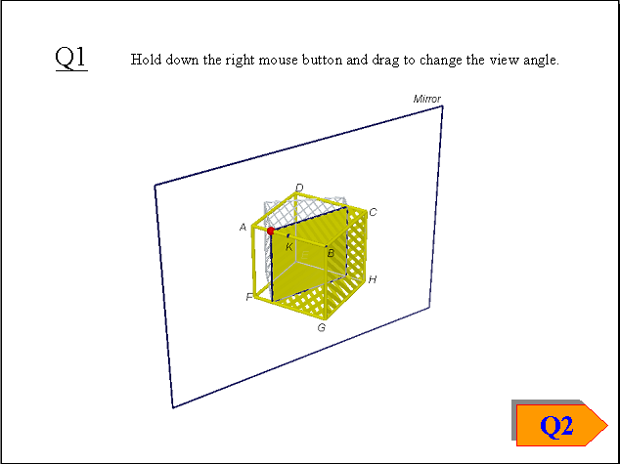

In the figure, the cube ABCDEFGH is divided into two halves by the mirror. The grey solid is the mirror image of the yellow half of the cube. K is the midpoint of AB.

(a) Does the mirror image coincide with the other half of the cube? Yes ◻ No ◻

(b) Drag the red point back and forth to rotate the mirror. Observe the change of the mirror image.
What are the positions of the red point when the mirror image coincides with the other half of the cube?

(c) If a plane divides a solid into two halves, and one half is the mirror image of the other, then the solid is said to have reflectional symmetry, and the plane is called the plane of reflection.
In Fig. 1, K, L, M, N are the midpoints of the edges. Fig. 1 shows one plane of reflection of the cube ABCDEFGH. Name this plane.

Plane of reflection:

Fig. 1
In Fig. 2 and 3, draw two other planes of reflection you observed in (b), and name the planes.
Plane of reflection: Plane of reflection:
Fig. 2 Fig. 3
Q2
Press ‘Q2’, the following figure is shown:
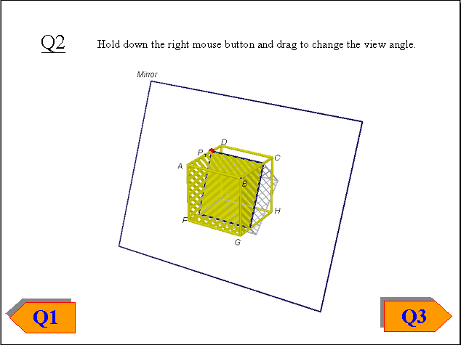
In the figure, the cube ABCDEFGH is divided into two halves by the mirror. The grey solid is the mirror image of the yellow half of the cube. P is the midpoint of AD.
Drag the red point back and forth to rotate the mirror. Observe when the mirror image coincides with the other half of the cube.
In each of Fig. 4 to Fig. 6, the unlabelled points are midpoint of the edges. Draw a plane of reflection you observed in each of the figure, and name the plane. If necessary, label the unlabelled points first before you name the planes.
Plane of reflection: Plane of reflection: Plane of reflection:
Fig. 4 Fig. 5 Fig. 6
Q3
Press ‘Q3’, the following figure is shown:
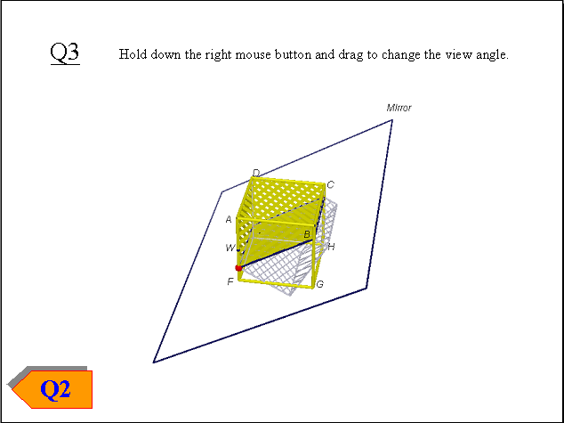
In the figure, the cube ABCDEFGH is divided into two halves by the mirror. The grey solid is the mirror image of the yellow half of the cube. W is the midpoint of AF.

Drag the red point back and forth to rotate the mirror. Observe when the mirror image coincides with the other half of the cube.
In each of Fig. 7 to Fig. 9, the unlabelled points are midpoint of the edges. Draw a plane of reflection you observed in each of the figure, and name the plane. If necessary, label the unlabelled points first before you name the planes.
Plane of reflection: Plane of reflection: Plane of reflection:
Fig. 7 Fig. 8 Fig. 9

Q4
In total, a cube has planes of reflection.
Learning: More about 3-D Figures – Reflectional Symmetry of the Cube

Reflectional Symmetry of the Cube (Answers)
Q1
Open the file “Ref-Cube.pps”, press ‘Start’ and you can see the following figure:

In the figure, the cube ABCDEFGH is divided into two halves by the mirror. The grey solid is the mirror image of the yellow half of the cube. K is the midpoint of AB.

(a) Does the mirror image coincide with the other half of the cube? Yes ◻ No ☑

(b) Drag the red point back and forth to rotate the mirror. Observe the change of the mirror image.
What are the positions of the red point when the mirror image coincides with the other half of the cube?
A、B or K

(c) If a plane divides a solid into two halves, and one half is the mirror image of the other, then the solid is said to have reflectional symmetry, and the plane is called the plane of reflection.
In Fig. 1, K, L, M, N are the midpoints of the edges. Fig. 1 shows one plane of reflection of the cube ABCDEFGH. Name this plane.

Plane of reflection: KLMN
Note: Accept any correct order.
Fig. 1
In Fig. 2 and 3, draw two other planes of reflection you observed in (b), and name the planes.
Plane of reflection: ACHF Plane of reflection: BDEG
Fig. 2 Fig. 3
Q2
Press ‘Q2’, the following figure is shown:
In the figure, the cube ABCDEFGH is divided into two halves by the mirror. The grey solid is the mirror image of the yellow half of the cube. P is the midpoint of AD.
Drag the red point back and forth to rotate the mirror. Observe when the mirror image coincides with the other half of the cube.
In each of Fig. 4 to Fig. 6, the unlabelled points are midpoint of the edges. Draw a plane of reflection you observed in each of the figure, and name the plane. If necessary, label the unlabelled points first before you name the planes.
Plane of reflection: PQRS Plane of reflection: CDFG Plane of reflection: ABHE
Fig. 4 Fig. 5 Fig. 6
Q3
Press ‘Q3’, the following figure is shown:
In the figure, the cube ABCDEFGH is divided into two halves by the mirror. The grey solid is the mirror image of the yellow half of the cube. W is the midpoint of AF.

Drag the red point back and forth to rotate the mirror. Observe when the mirror image coincides with the other half of the cube.
In each of Fig. 7 to Fig. 9, the unlabelled points are midpoint of the edges. Draw a plane of reflection you observed in each of the figure, and name the plane. If necessary, label the unlabelled points first before you name the planes.
Plane of reflection: WXYZ Plane of reflection: AGHD Plane of reflection: BCEF
Fig. 7 Fig. 8 Fig. 9

Q4
In total, a cube has 9 planes of reflection.

