Rotational Symmetry of the Cube

Key Stage | ： | 3
Dimension | ： | Measures, Shape and Space Dimension
Learning Unit | ： | More about 3-D Figures
Basic Competency | ： | KS3-MS8-2  Name axes of rotational symmetries of cubes
Introduction：
The teacher distributes the worksheet “Rotational Symmetry of the Cube” to each student.
Students use the file “Rot-Cube.html” to complete the worksheet. (Cabri 3D Ver 2.1.2 (evaluation copy could be downloaded) has to be installed first.)
During the activity, students drag the axis of rotation to different positions of the cube, and rotate the cube about the axis of rotation to investigate the order of rotational symmetry for the axis.
To demonstrate to students the order of rotational symmetry for the axis, the teacher could use right-button drag to see the cube in the following views:

The teacher asks students to summarize their findings in the table at the end of the worksheet.

Learning Unit：More about 3-D Figures – Rotational Symmetry of the Cube

Rotational Symmetry of the Cube

Question 1
Open the file “Rot-Cube.html”. The following figure is shown in the screen.
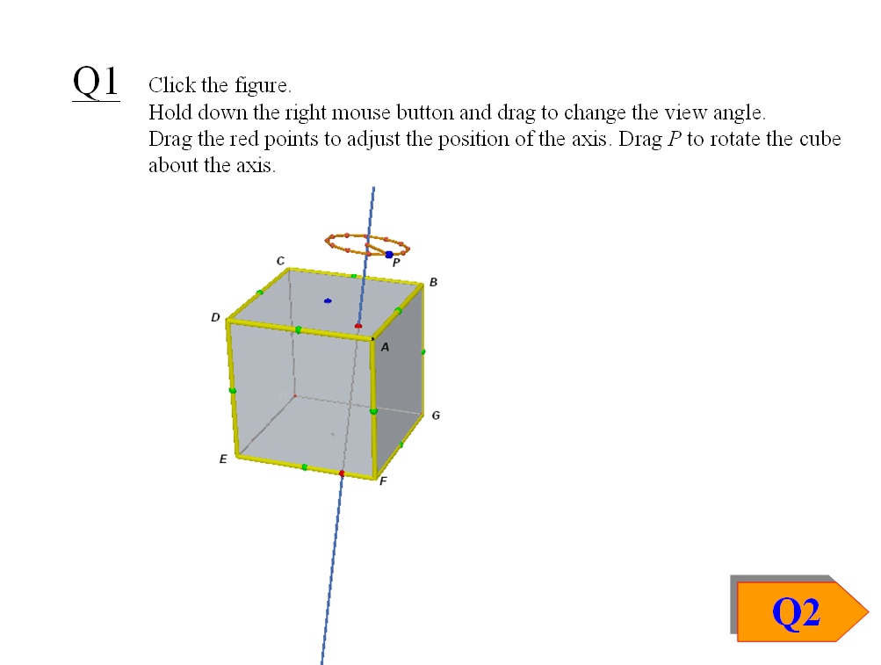
The figure shows a cube ABCDEFGH and a line passes through the cube. The cube can be rotated about the line by dragging P on the circle, which can be dragged up and down along the axis. The line is called an axis of rotation.

The position of the axis can be adjusted by moving the red points at the top ABCD and at the bottom EFGH. Use right-button drag to view the figure at different perspective.
Fig. 1
Drag the red point at the top to A, and drag the red point at the bottom to F, as shown in Fig. 1.
Drag P to rotate the cube about this axis for one complete revolution. Observe the rotation of the cube. The yellow frame indicates the original position of the cube.
(a) Does the cube repeat itself before it is rotated back to the starting position?
Yes □ No □
If the figure repeats itself more than once in a complete revolution (including the repetition when it is rotated back to the starting position), the figure is said to have a rotational symmetry, in this case the axis is called an axis of rotational symmetry. The number of times it repeats itself is called the order of the rotational symmetry.

(b) Drag the red point at the top to the blue point which is the centre of face.
Drag the red point at the bottom to a suitable position so that the axis becomes an axis of rotational symmetry. Draw this axis in Fig. 2.
The order of rotational symmetry is .
(c) Drag the red point at the top to A.
Drag the red point at the bottom to a suitable position so that the axis becomes an axis of rotational symmetry. Draw this axis in Fig. 2.
The order of rotational symmetry is .

(d) Drag the red point at the top to the green point at AD, which is the mid-point of the edge.
Drag the red point at the bottom to a suitable position so that the axis becomes an axis of rotational symmetry. Draw this axis in Fig. 2.
The order of rotational symmetry is .

Fig. 2

(e) Observe the axes you draw in Fig. 2.
The three axes pass meet in a single point. Describe this point.

If an axis does not pass through this point, could it be an axis of rotational symmetry of the cube? Yes □ No □

Question 2
Click the button “Q2”. The following figure is shown in the screen.
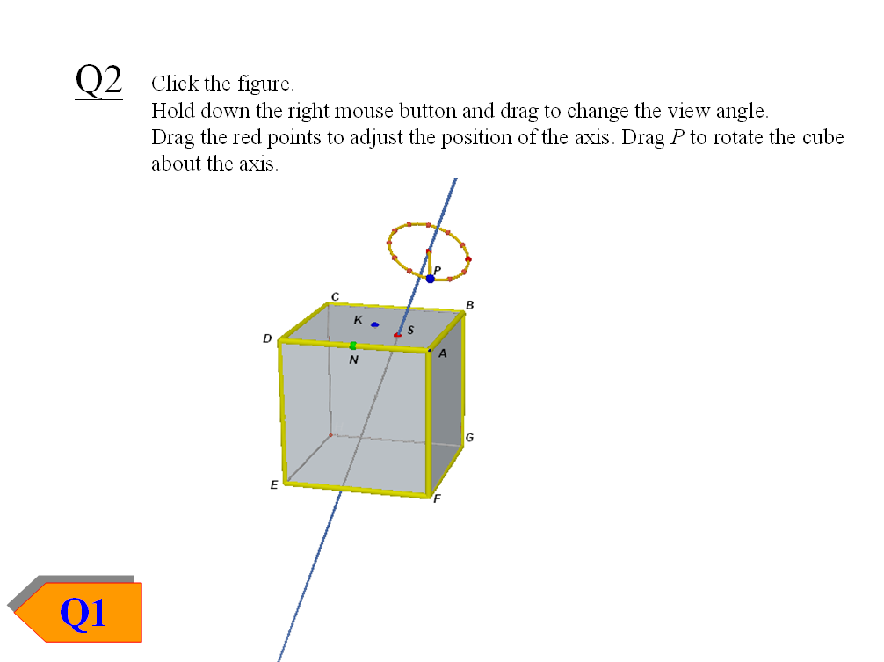
In the figure, the blue point K is the centre of the face ABCD, and the green point N is the mid-point of the edge AD.
The axis of rotation can be adjusted by dragging S between the K, N and A, in a way that the axis always passes through the centre of the cube.
Use right-button drag to view the cube at different perspective.

Drag S to any other position such that the axis does NOT pass through K, N and G. The following figure shows an example. Rotate the cube about the axis by dragging P.
(a) Is the axis an axis of rotational symmetry? Yes □ No □
(b) If an axis passes through the centre of the cube, must it be an axis of rotational
symmetry? Yes □ No □

(c) Drag S to the position of K.
(i) Right-button drag the figure to view the figure along the axis of rotation so that the axis almost becomes a point. Rotate the cube for one revolution.
Imagine the ideal case when you view the figure in the perspective that the axis becomes exactly a point. Draw the cube and the axis you will see in the following space. Denote the axis of rotation by “×”.

What is the order of rotational symmetry of this axis? Ans.:
(ii) In the figure, draw all the axes of rotational symmetry of the order in (i).
(1) How many axes have been drawn? Ans.:
(2) Name all the axes drawn in the above figure.

(d) Drag S to the position of A.
(i) Right-button drag the figure to view the figure along the axis of rotation so that the axis almost becomes a point. Rotate the cube for one revolution.
Imagine the ideal case when you view the figure in the perspective that the axis becomes exactly a point. Draw the cube and the axis you will see in the following space. Denote the axis of rotation by “×”.

What is the order of rotational symmetry of this axis? Ans.:
(ii) In the figure, draw all the axes of rotational symmetry of the order in (i).
(1) How many axes have been drawn? Ans.:
(2) Name all the axes drawn in the above figure.

(e) Drag S to the position of N.
(i) Right-button drag the figure to view the figure along the axis of rotation so that the axis almost becomes a point. Rotate the cube for one revolution.
Imagine the ideal case when you view the figure in the perspective that the axis becomes exactly a point. Draw the cube and the axis you will see in the following space. Denote the axis of rotation by “×”.

What is the order of rotational symmetry of this axis? Ans.:
(ii) In the figure, draw all the axes of rotational symmetry of the order in (i).
(1) How many axes have been drawn? Ans.:
(2) Name all the axes drawn in the above figure.

(f) Summarize the results of (c), (d) and (e) in the following table.
Rotational Symmetry of order | Number of axes of symmetry
Total:

End
Learning Unit：More about 3-D Figures – Rotational Symmetry of the Cube

Rotational Symmetry of the Cube (Answers)

Question 1
Open the file “Rot-Cube.pps”. The following figure is shown in the screen.
The figure shows a cube ABCDEFGH and a line passes through the cube. The cube can be rotated about the line by dragging P on the circle, which can be dragged up and down along the axis. The line is called an axis of rotation.

The position of the axis can be adjusted by moving the red points at the top ABCD and at the bottom EFGH. Use right-button drag to view the figure at different perspective.
Fig. 1
Drag the red point at the top to A, and drag the red point at the bottom to F, as shown in Fig. 1.
Drag P to rotate the cube about this axis for one complete revolution. Observe the rotation of the cube. The yellow frame indicates the original position of the cube.
(a) Does the cube repeat itself before it is rotated back to the starting position?
Yes □ No ☑
If the figure repeats itself more than once in a complete revolution (including the repetition when it is rotated back to the starting position), the figure is said to have a rotational symmetry, in this case the axis is called an axis of rotational symmetry. The number of times it repeats itself is called the order of the rotational symmetry.

(b) Drag the red point at the top to the blue point which is the centre of face.
Drag the red point at the bottom to a suitable position so that the axis becomes an axis of rotational symmetry. Draw this axis in Fig. 2.
The order of rotational symmetry is 4 .
(c) Drag the red point at the top to A.
Drag the red point at the bottom to a suitable position so that the axis becomes an axis of rotational symmetry. Draw this axis in Fig. 2.
The order of rotational symmetry is 3 .

(d) Drag the red point at the top to the green point at AD, which is the mid-point of the edge.
Drag the red point at the bottom to a suitable position so that the axis becomes an axis of rotational symmetry. Draw this axis in Fig. 2.
The order of rotational symmetry is 2 .
Fig. 2

(e) Observe the axes you draw in Fig. 2.
The three axes pass meet in a single point. Describe this point.
This point is the centre of the cube.
If an axis does not pass through this point, could it be an axis of rotational symmetry of the cube? Yes □ No ☑

Question 2
Click the button “Q2”. The following figure is shown in the screen.
In the figure, the blue point K is the centre of the face ABCD, and the green point N is the mid-point of the edge AD.
The axis of rotation can be adjusted by dragging S between the K, N and A, in a way that the axis always passes through the centre of the cube.
Use right-button drag to view the cube at different perspective.

Drag S to any other position such that the axis does NOT pass through K, N and G. The following figure shows an example. Rotate the cube about the axis by dragging P.
(a) Is the axis an axis of rotational symmetry? Yes □ No ☑
(b) If an axis passes through the centre of the cube, must it be an axis of rotational
symmetry? Yes □ No ☑

(c) Drag S to the position of K.
(i) Right-button drag the figure to view the figure along the axis of rotation so that the axis almost becomes a point. Rotate the cube for one revolution.
Imagine the ideal case when you view the figure in the perspective that the axis becomes exactly a point. Draw the cube and the axis you will see in the following space. Denote the axis of rotation by “×”.
What is the order of rotational symmetry of this axis? Ans.: 4
(ii) In the figure, draw all the axes of rotational symmetry of the order in (i).
(1) How many axes have been drawn? Ans.: 3
(2) Name all the axes drawn in the above figure.
II’, JJ’, KK’
(d) Drag S to the position of A.
(i) Right-button drag the figure to view the figure along the axis of rotation so that the axis almost becomes a point. Rotate the cube for one revolution.
Imagine the ideal case when you view the figure in the perspective that the axis becomes exactly a point. Draw the cube and the axis you will see in the following space. Denote the axis of rotation by “×”.
What is the order of rotational symmetry of this axis? Ans.: 3
(ii) In the figure, draw all the axes of rotational symmetry of the order in (i).
(1) How many axes have been drawn? Ans.: 4
(2) Name all the axes drawn in the above figure.
AH, BE, CF, DG

(e) Drag S to the position of N.
(i) Right-button drag the figure to view the figure along the axis of rotation so that the axis almost becomes a point. Rotate the cube for one revolution.
Imagine the ideal case when you view the figure in the perspective that the axis becomes exactly a point. Draw the cube and the axis you will see in the following space. Denote the axis of rotation by “×”.
What is the order of rotational symmetry of this axis? Ans.: 2
(ii) In the figure, draw all the axes of rotational symmetry of the order in (i).
(1) How many axes have been drawn? Ans.: 6
(2) Name all the axes drawn in the above figure.
LX, MY, NZ, OW, QT, RV
(f) Summarize the results of (c), (d) and (e) in the following table.
Rotational Symmetry of order | Number of axes of symmetry
4 | 3
2 | 6
3 | 4
Total: | 13

End

