Primary School
Primary 1 – Time
Worksheet 4.1
Name： ( ) Class：1_____
Date：
Draw the hour hand according to the time.

1 | 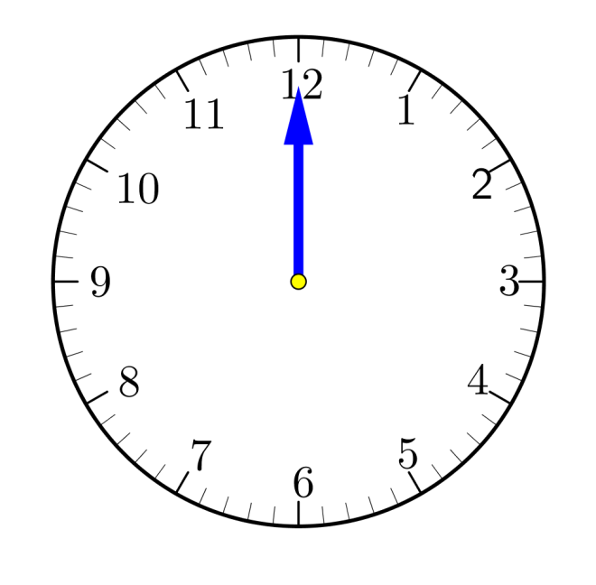 | 2
 | 11 o’clock |  | 12 o’clock
3 |  | 4
 | 6 o’clock |  | 8 o’clock
(Set your own question)
Write down a time at your choice and draw the hour hand.

5 |  | 6
 | ____ o’clock |  | ____ o’clock
7 |  | 8
 | ____ o’clock |  | ____ o’clock

