Primary School
Primary 1 – Time
Worksheet 4.2
Name： ( ) Class：1_____
Date：
Draw the hour hand according to the time.

1 | 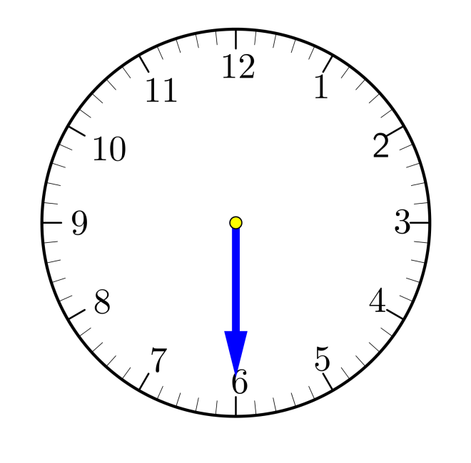 | 2
 | half past 3 |  | half past 6
3 |  | 4
 | half past 9 |  | half past 12

(Set your own question)
Write down a time at your choice and draw the hour hand.

5 |  | 6
 | half past ____ |  | half past ____
7 |  | 8
 | half past ____ |  | half past ____

