Primary School

Primary 1 – Time

Worksheet 1

Name： ( ) Class：1_____

Date：



B

A



C

D

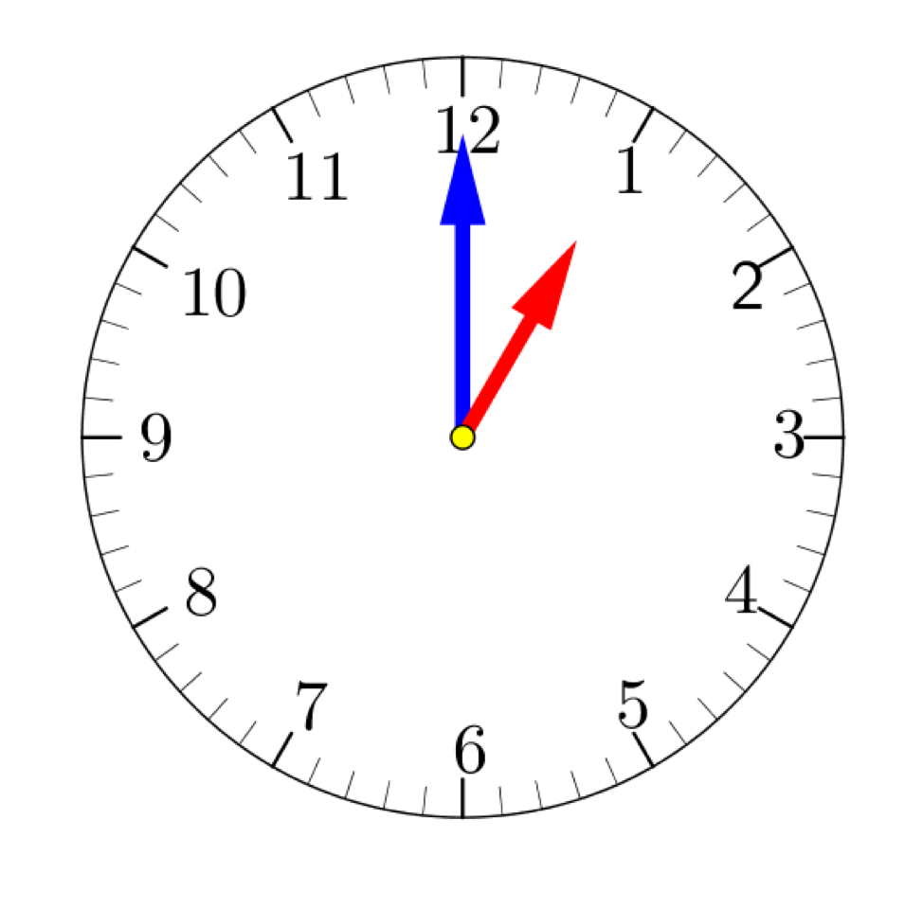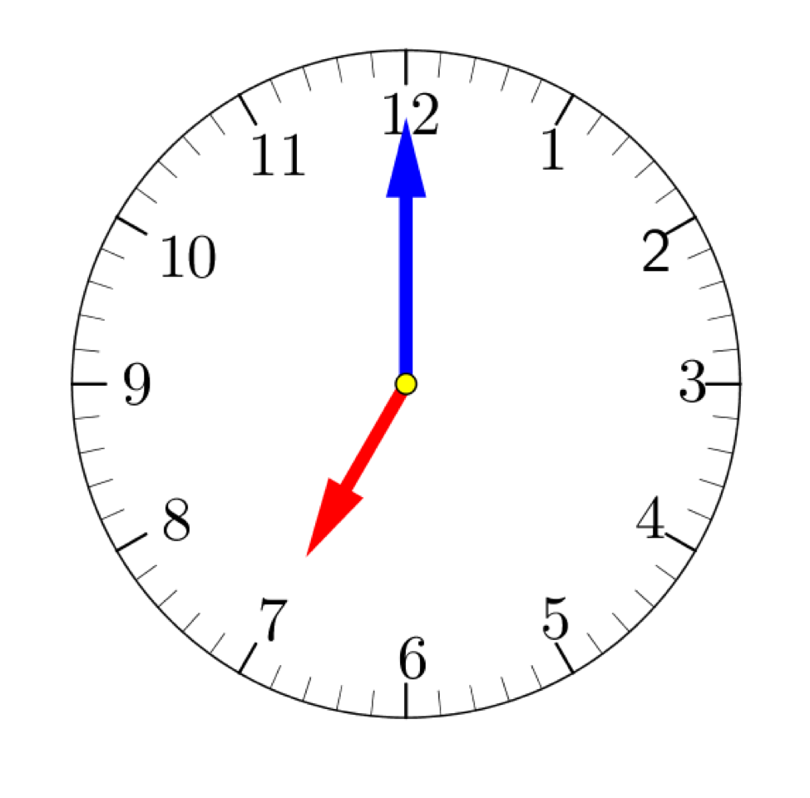What are they doing at the following time? Write down the letter in the bracket.

1. 2.

( ) ( )

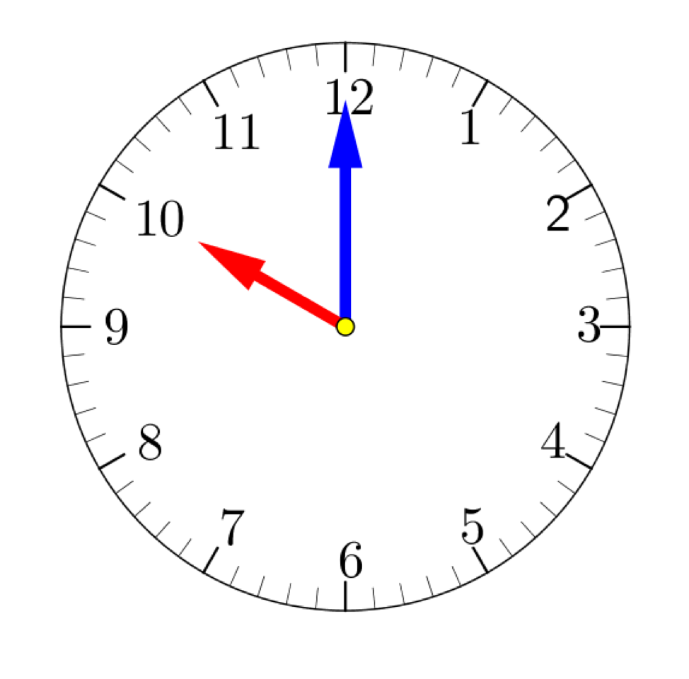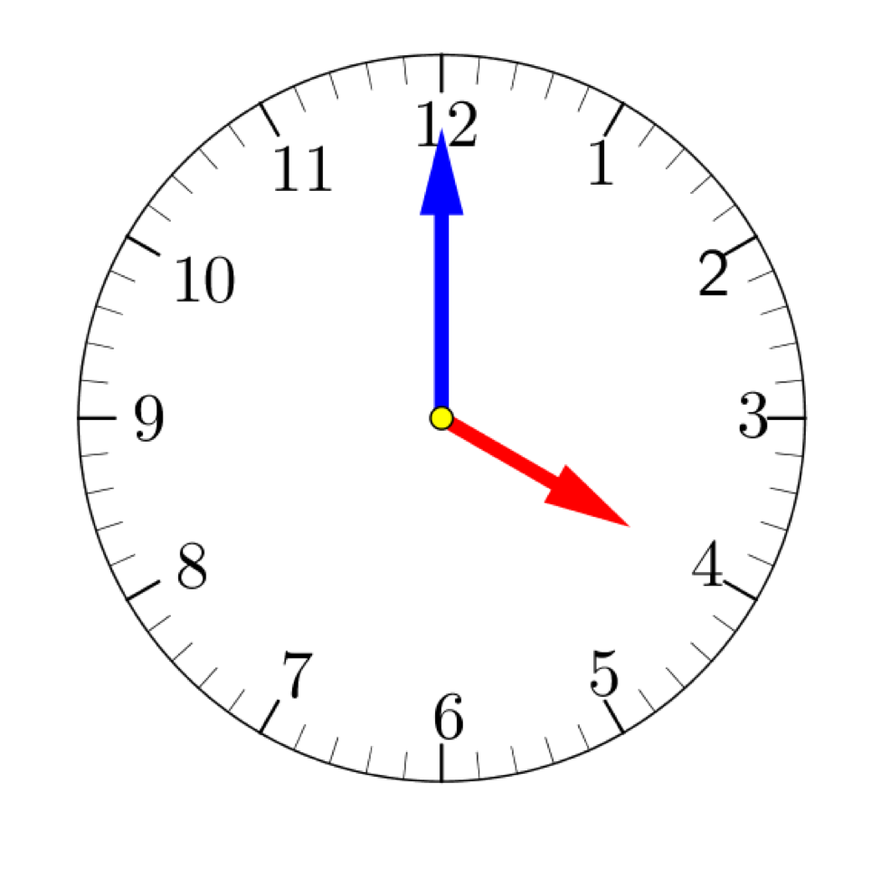   
3. 4.

( ) ( )

5. Circle the **minute hand**.

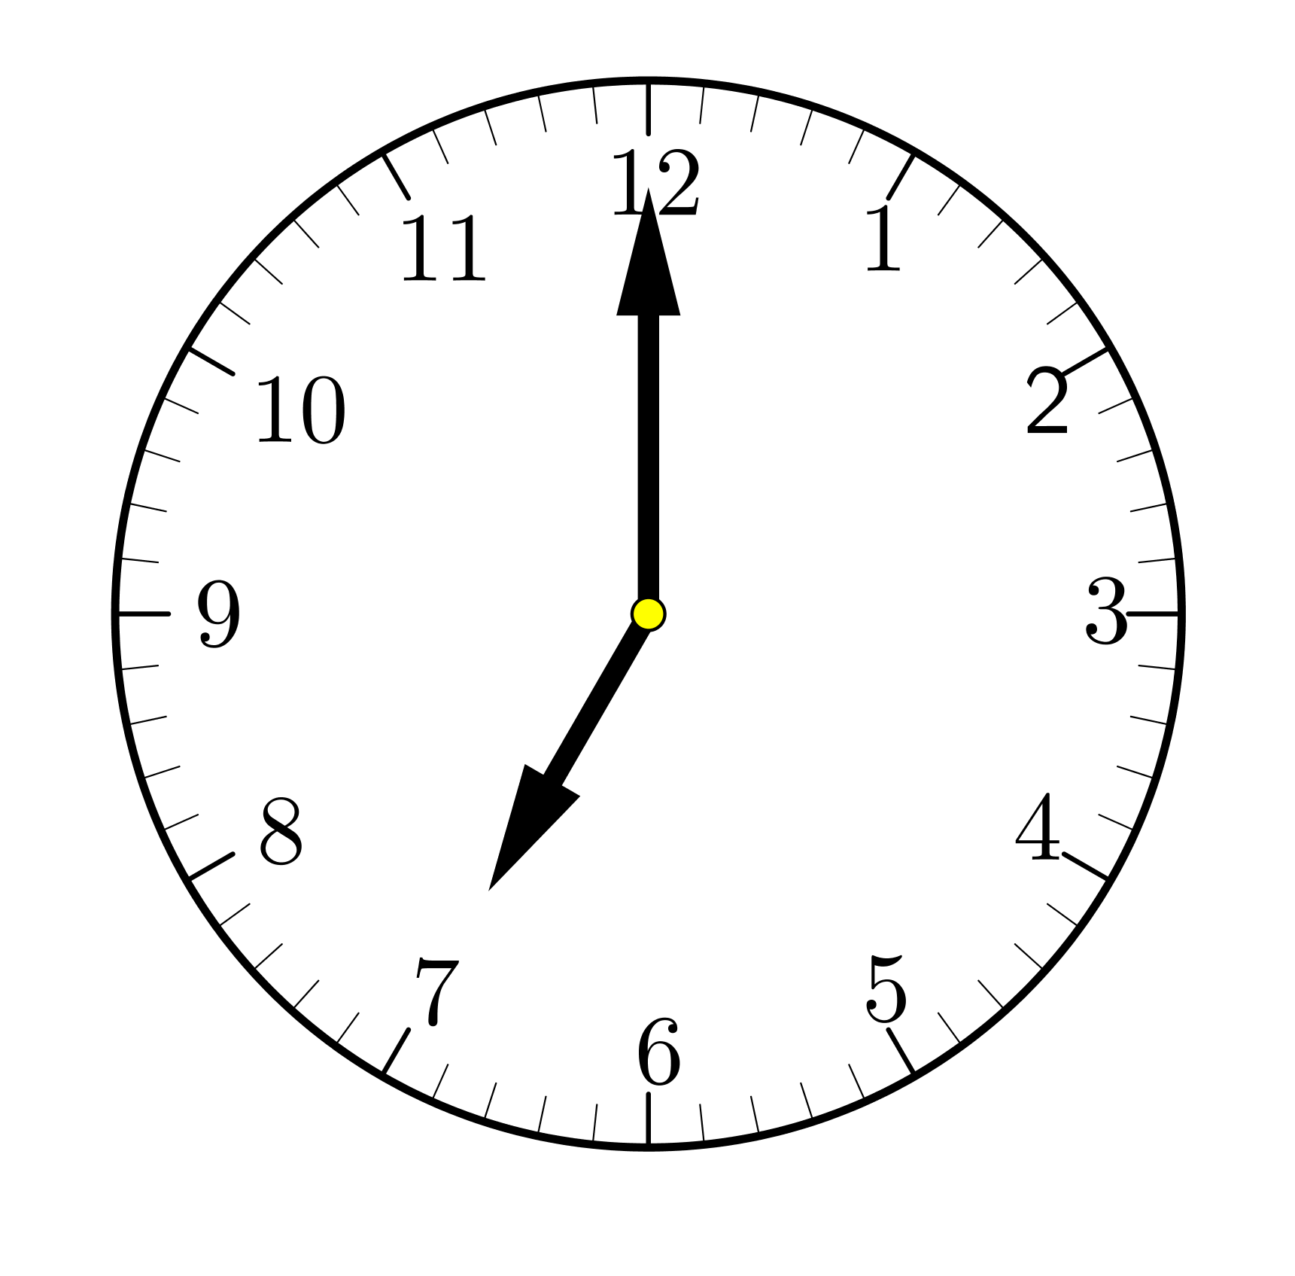

6. Circle the **hour hand**.

