Primary School

Primary 1 – Time

Worksheet 2

Name： ( ) Class：1_____

Date：

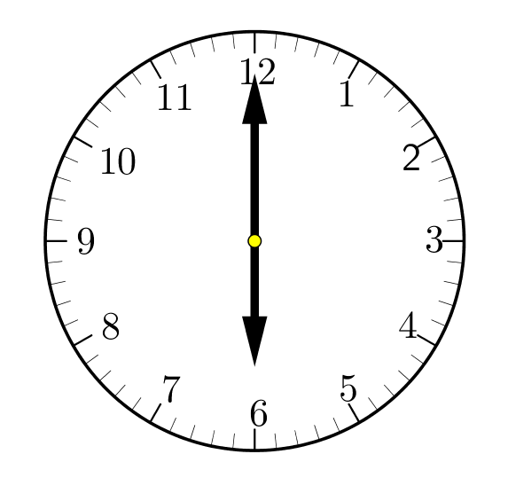Write down the time for each of the clock below.

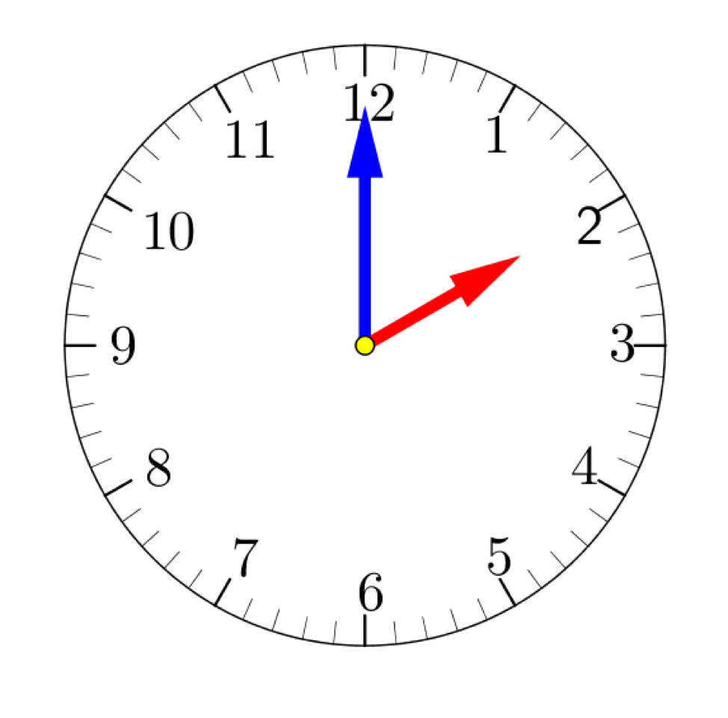1. 2.

_____ o’clock _____ o’clock

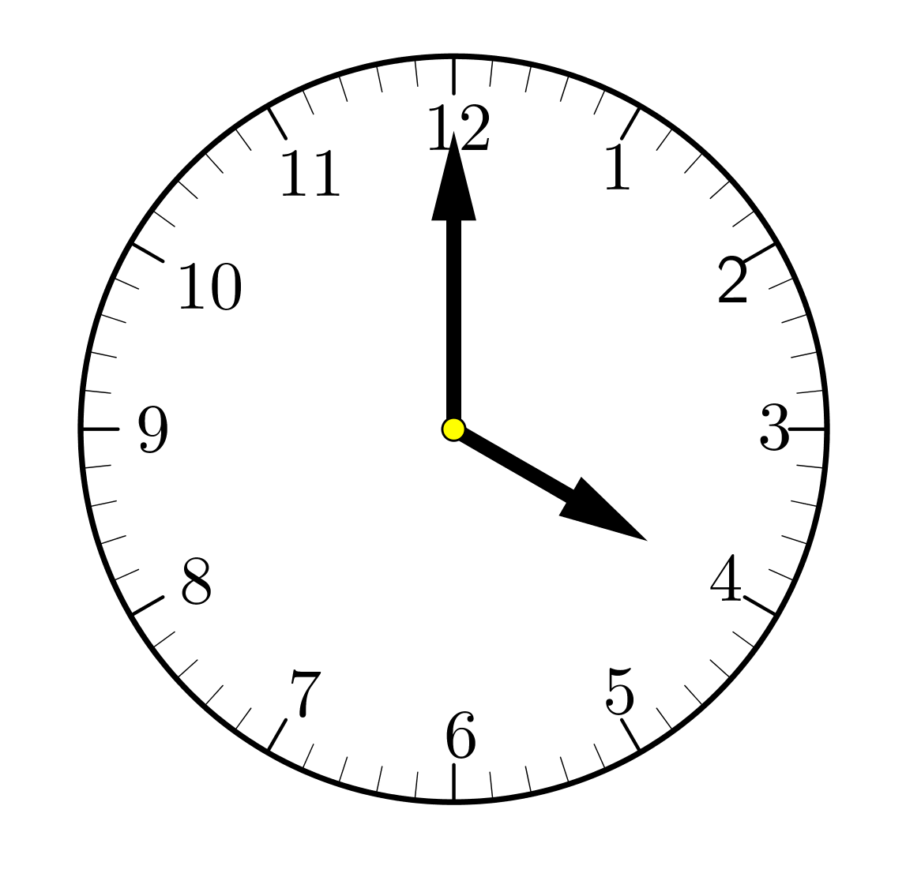

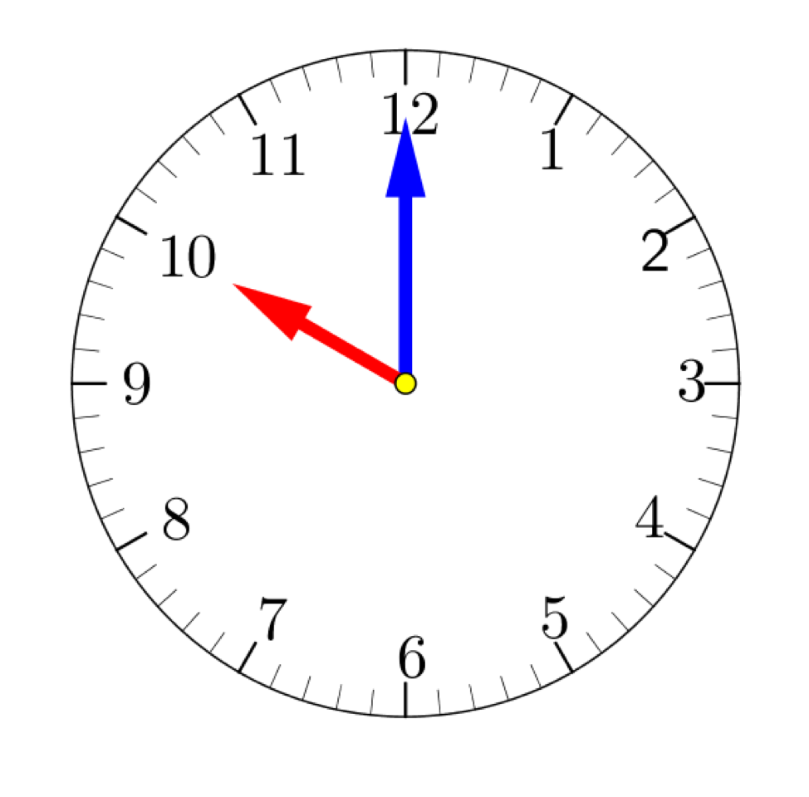 3. 4.

_____ o’clock _____ o’clock

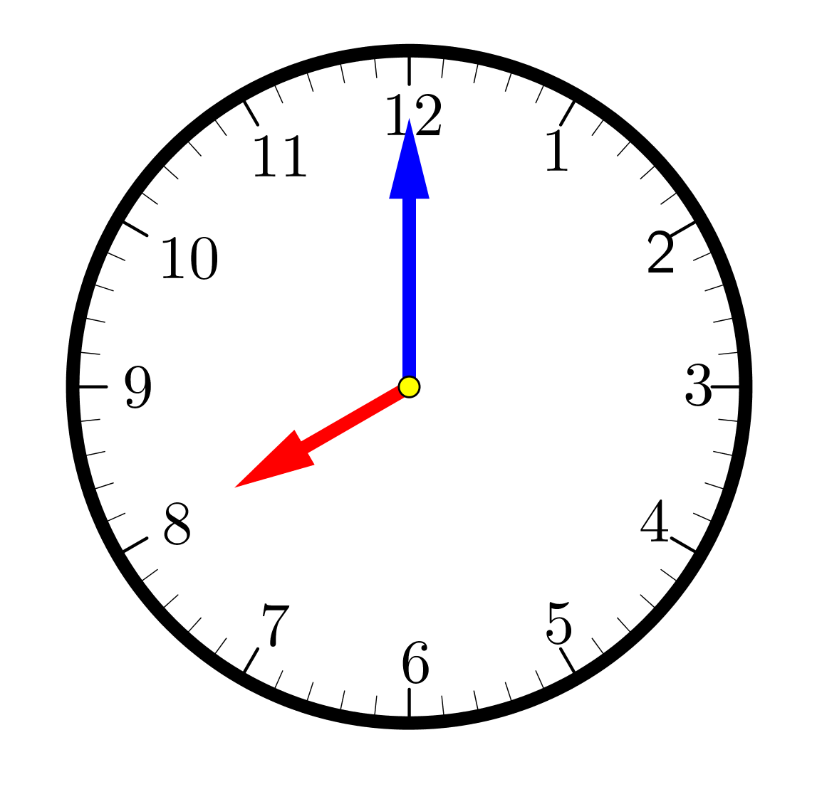

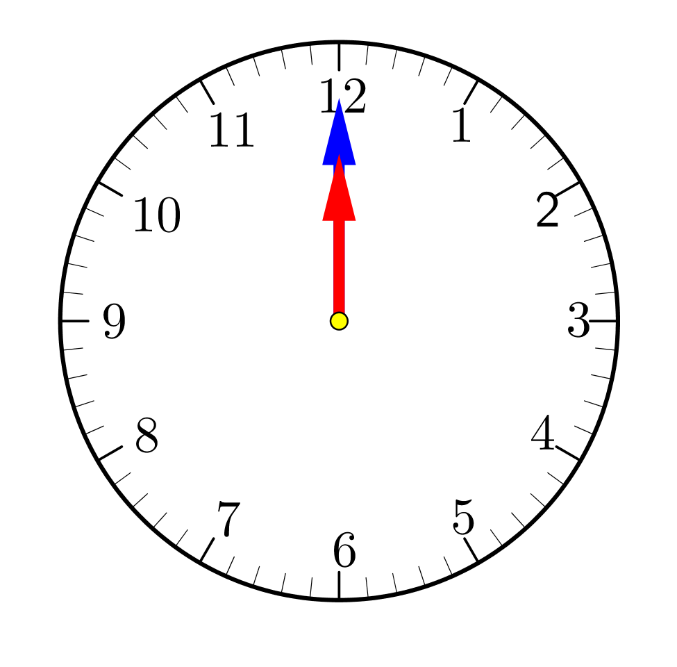5. 6.

_____ o’clock _____ o’clock