Primary School

Primary 1 – Time

Worksheet 3

Name： ( ) Class：1_____

Date：

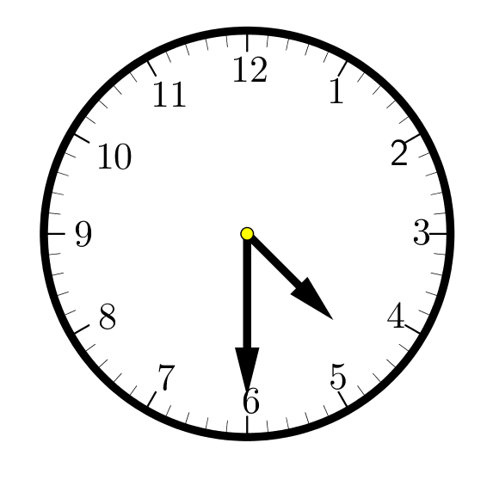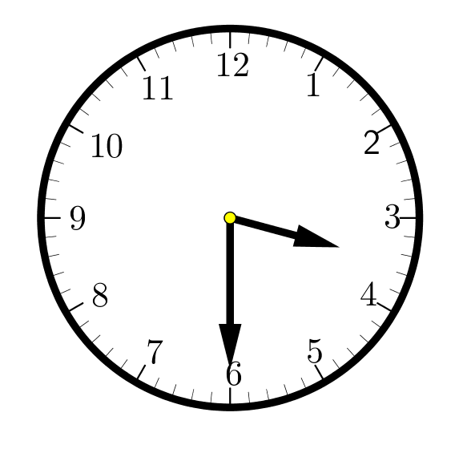 Write down the time for each of the clock below.

1. 2.

Half past _____ Half past _____

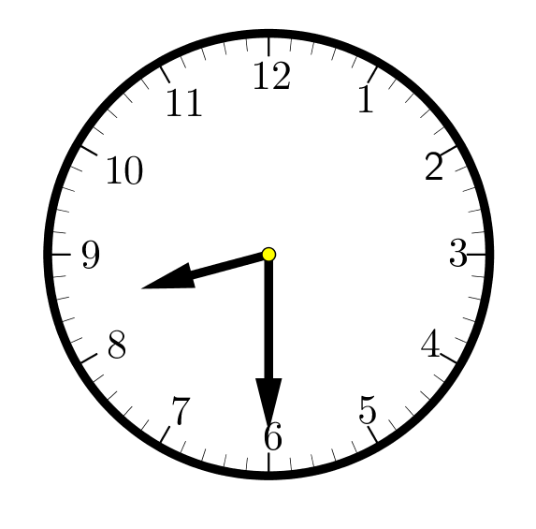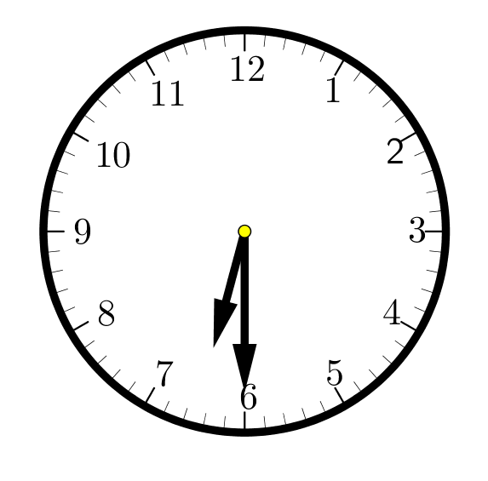

3. 4.

Half past _____ Half past _____

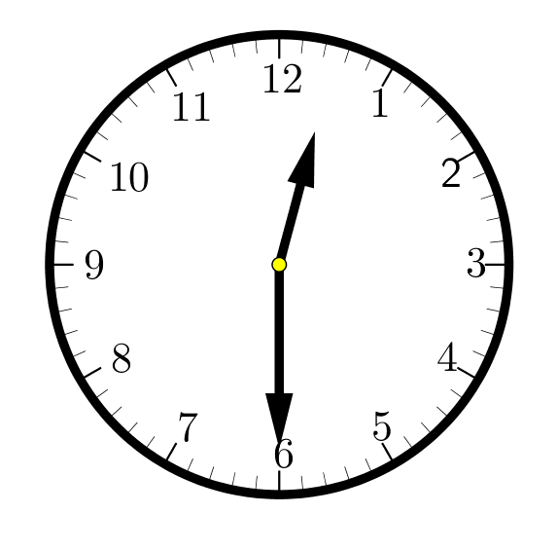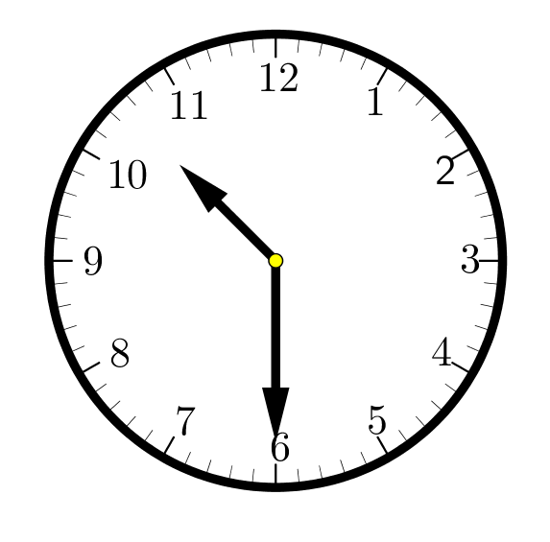

5. 6.

Half past _____ Half past _____