Primary School

Primary 2 – Weight

Group Worksheet 1 - **Annotation**

Instruct students to record the result of weights. If object A is lighter than object B, write letter A to the left of letter B in the box. If object A is heavier than object B, write letter A to the right of letter B. Remind students to leave enough space between letters.

Primary School

Primary 2 – Weight

Group Worksheet 1

Name： ( ) Class：2_____

Date：

**Group Discussion – Part A**

1. Which one is the heaviest and which one is the lightest? Record the result in the table.



A



B



A



C

|  |  |  |  |  |  |  |  |
| --- | --- | --- | --- | --- | --- | --- | --- |
| A | | | | | | | |
| lighter |  |  |  |  |  |  | heavier |

1. Which one is the heaviest and which one is the lightest? Record the result in the table.



C

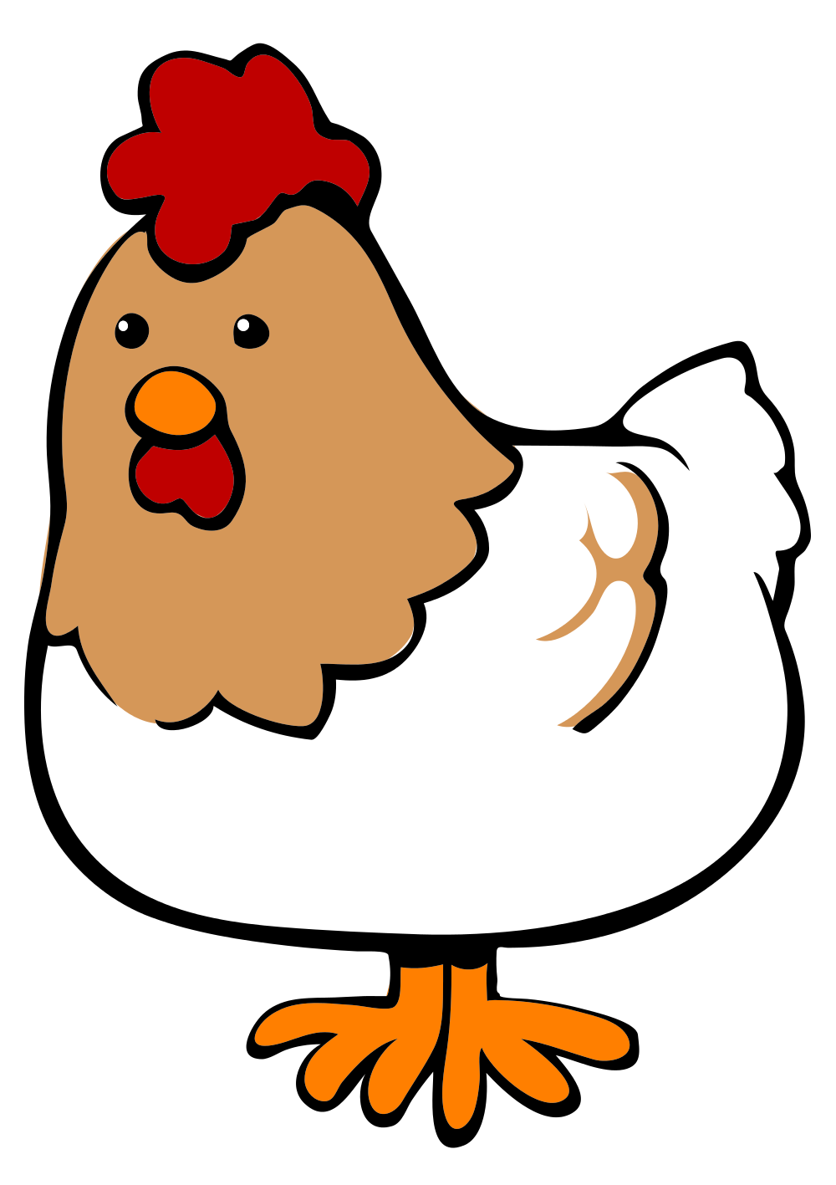

D



C



E

|  |  |  |  |  |  |  |  |
| --- | --- | --- | --- | --- | --- | --- | --- |
| D | | | | | | | |
| lighter |  |  |  |  |  |  | heavier |

1. Which one is the heaviest and which one is the lightest? Record the result in the table.



A



C



A

B

|  |  |  |  |  |  |  |  |
| --- | --- | --- | --- | --- | --- | --- | --- |
| C | | | | | | | |
| lighter |  |  |  |  |  |  | heavier |

**Group Discussion – Part B**

1. Which one is heavier, the frog or the fox? Why?



1. Which one is heavier, a banana or a slice of watermelon?



Primary School

Primary 2 – Weight

Group Worksheet 1 – **Answers**

Name： ( ) Class：2_____

Date：

**Group Discussion – Part A**

1. Which one is the heaviest and which one is the lightest? Record the result in the table.



A



B



A



C

|  |  |  |  |  |  |  |  |
| --- | --- | --- | --- | --- | --- | --- | --- |
| C A B | | | | | | | |
| lighter |  |  |  |  |  |  | heavier |

1. Which one is the heaviest and which one is the lightest? Record the result in the table.



C



D



C



E

|  |  |  |  |  |  |  |  |
| --- | --- | --- | --- | --- | --- | --- | --- |
| E C D | | | | | | | |
| lighter |  |  |  |  |  |  | heavier |

1. Which one is the heaviest and which one is the lightest? Record the result in the table.



A



C



A

B

|  |  |  |  |  |  |  |  |
| --- | --- | --- | --- | --- | --- | --- | --- |
| （B’s position cannot be determined） C A | | | | | | | |
| lighter |  |  |  |  |  |  | heavier |

**Group Discussion – Part B**

1. Which one is heavier, the frog or the fox? Why?   
      
   The fox. The answer can be revealed by removing the apple on each side of the balance.



1. Which one is heavier, a banana or a slice of watermelon?



Banana.