Primary School

Primary 3 – Perpendicular and Parallel

Circles in Figure

Name： ( ) Class：3

Date：

1.

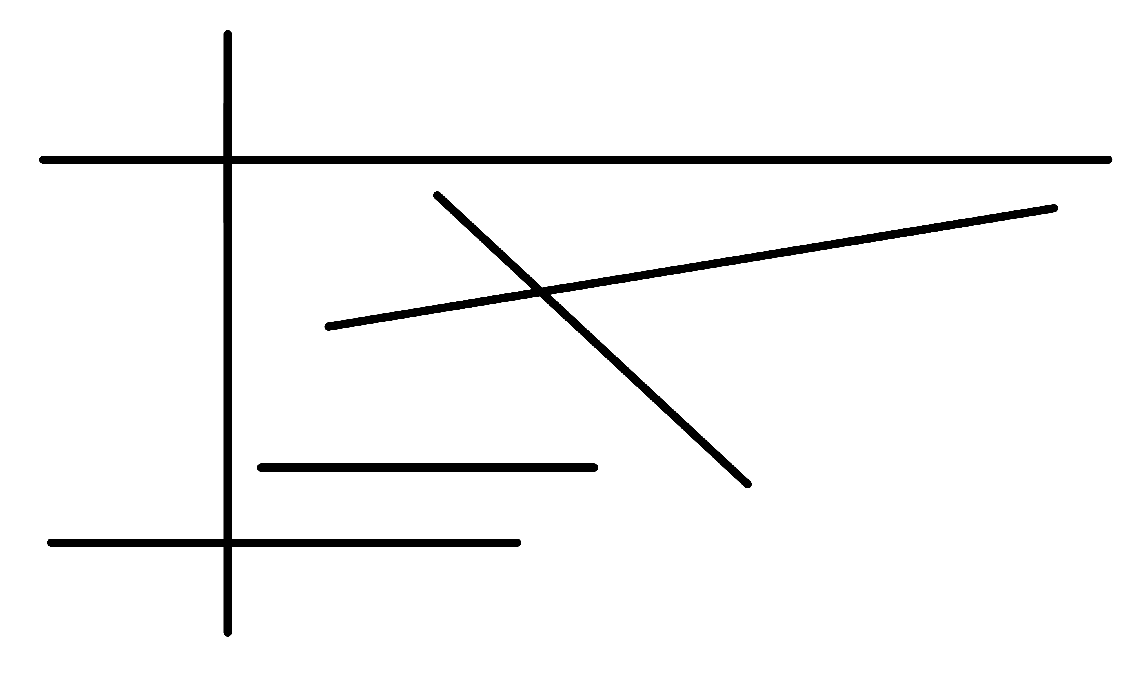

Can you find the following pictures in the above figure? Circle them in the figure.

|  |  |  |  |
| --- | --- | --- | --- |
|  | 圖片/Q4.1.png |  | 圖片/Q4.2.png |
|  | 圖片/Q4.3.png |  | 圖片/Q4.4.png |

2.

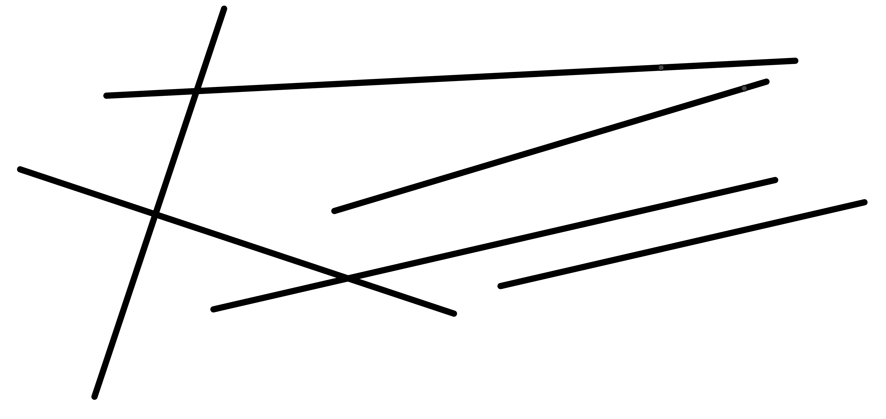

Can you find the following pictures in the above figure? Circle them in the figure.

|  |  |  |  |
| --- | --- | --- | --- |
|  | 圖片/Q5.1.png |  | 圖片/Q5.2.png |
|  | 圖片/Q5.3.png |  | 圖片/Q5.4.png |