Perpendicular and Parallel – Teaching Guideline

30 minutes for each lesson, 6 lessons in total

Number of students: around 10 to 15

Lesson 1

Activity 1: Chopsticks (30 minutes)

* Throw a pair of chopsticks onto a table and don’t let students see the pattern.
* Let students guess the pattern of the chopsticks.
* Divide students into groups of 3 and distribute each group 4 pieces of paper and at least 1 ruler.
* Let students draw the possible patterns on paper.
* Teacher can show some possible patterns prepared in advance, especially the parallel and perpendicular patterns. (Since students are unlikely to think of these patterns.)
* Post students’ drawings on board.
* Let students observe and classify the drawings.
* Students may first classify the drawings into “intersecting” and “non-intersecting” cases. Teacher can guide students to further classify the “non-intersecting” drawings into parallel and non-parallel cases. Teacher can point out that some lines will get closer and closer when extended, and thus bring to the point that parallel lines will never intersect even when extended. Subsequently, teacher can guide students to further classify the “intersecting” drawings into “perpendicular” and “non-perpendicular” cases.

Lesson 2

“Circles in Figure” Powerpoint (30 minutes)

Teacher show the following figure of line segments on screen  
(If screen is unavailable, teacher can divide the following figure into left and right halves and then print each half on a piece of A3 paper. Then the two pieces of A3 paper can be combined into the A2 size and be stuck on board.)

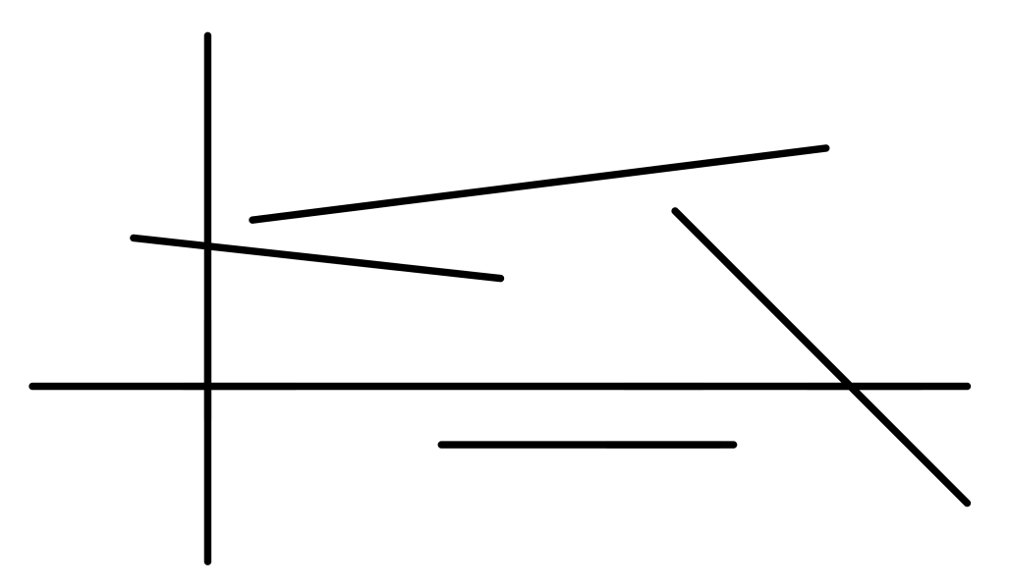

Subsequently, teacher can distribute the following circles to students (or just show them in hand).

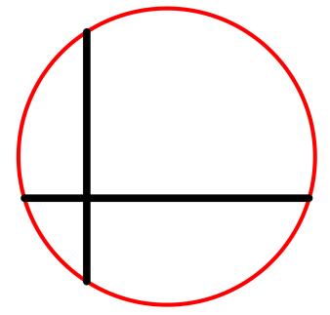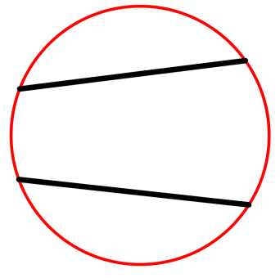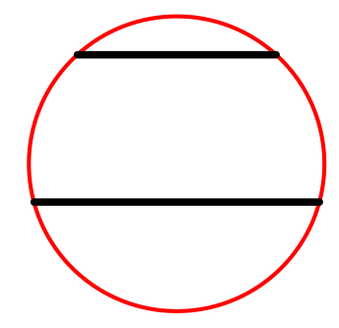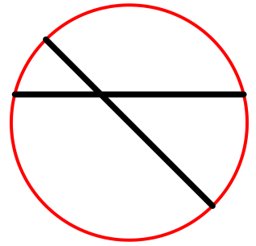

Students need to discuss and find out which parts do the circles come from the figure. If students need to demonstrate which parts do the circles come from the figure, they may place circles on the screen to demonstrate their ideas. The figure may be enlarged or diminished to suit the size of circles.

Assessment

Finally, an assessment can be conducted by asking students to circle the figure printed on a worksheet to illustrate which parts do the circles come from the figure.

Lesson 3 and 4

* Exercises in textbook will be discussed (with the part of grid skipped)
* Identify perpendicular lines
* 1. Draw perpendicular lines by imitating objects with right angle.  
  2. Draw perpendicular lines along two rulers placed as a T-shape.
* Identify parallel lines
* 1. Draw parallel lines along the two sides of a ruler.  
  2. Draw parallel lines with two rulers: one fixed and one moves along the other.
* Students fold paper to form perpendicular creases (play video clip)  
  It is suggested to use circle paper as it has no distracting parallel and perpendicular edges so that students can focus at their creases formed by folding.
* Similarly, students fold paper to form parallel creases (play video clip)
  + Challenge for quick finishers:  
    E.g.: A crease and a point (not on the crease) are marked on paper. Students are challenged to form a crease passing through the point and perpendicular / parallel to the given crease.

Lesson 5 and 6

“How to draw on grid” Powerpoint

Help students to be familiar with grid.

For example:

Draw the given figure to the right with a ruler.

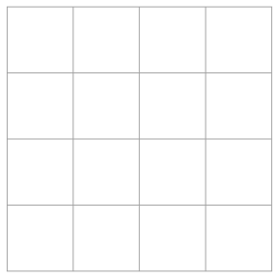

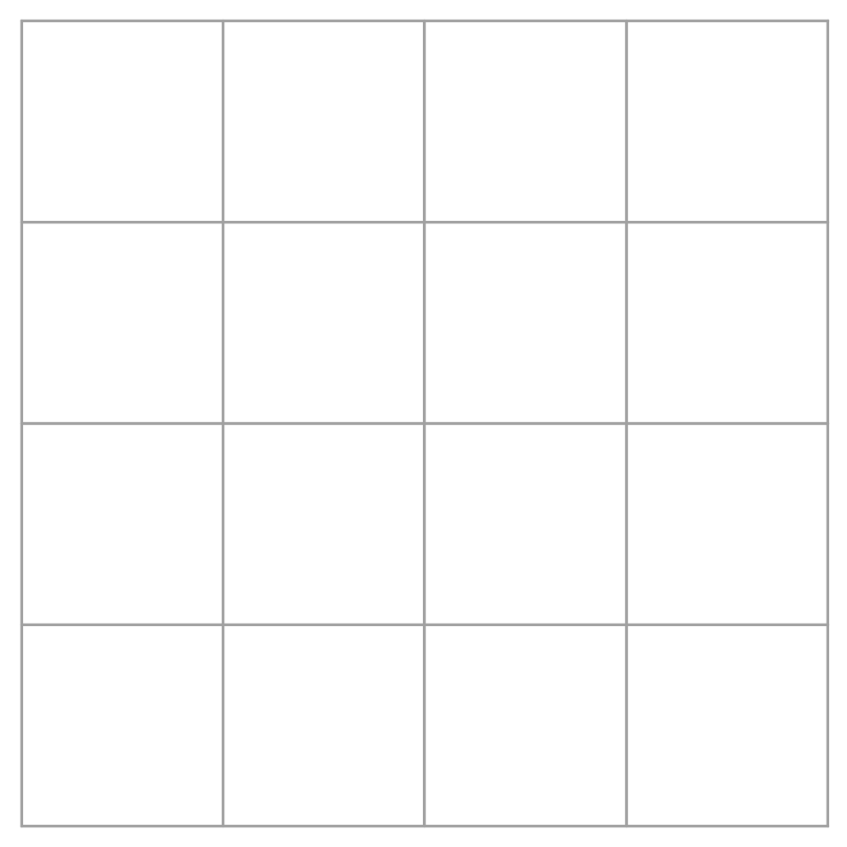

If students find this question difficult, teacher may use another provided Powerpoint to explain the steps.

Figures of question 2 to 5:



After these activities, students may try to draw perpendicular and parallel lines.

For example:

1. A line is given on grid paper. Students are required to draw a line perpendicular / parallel to the given line.
2. A line and a point (not on the crease) are given on grid paper. Students are required to draw a line passing through the point and perpendicular / parallel to the given line.