**Estimate the answers**

Name： ( ) Class： Date：

Read the questions carefully and circle the correct answers.

1. Which of the following is the most suitable expression to estimate the value of $\text{11.8} \text{÷} \text{3.9}$?
   1. **11 ÷ 3**
   2. **11 ÷ 4**
   3. **12 ÷ 3**
   4. **12 ÷ 4**
2. Which of the following is the most suitable expression to estimate the value of $\text{14}\frac{\text{7}}{\text{8}} \text{×} \frac{\text{20}}{\text{11}}$?
   1. **15 $×$ 1**
   2. **15 $×$ 2**
   3. **14 $×$ 1**
   4. **14 $×$**  **2**
3. Which of the following is the most suitable expression to estimate the value of $\text{7.99} \text{÷} \text{4.11}$?
   1. **7 ÷ 5**
   2. **7 ÷ 4**
   3. **8 ÷ 5**
   4. **8 ÷ 4**
4. Which of the following is the most suitable expression to estimate the value of $\text{15}\frac{\text{2}}{9}\text{÷}\text{ 3}-\text{2}\frac{\text{15}}{\text{16}}$?
   1. **15 ÷ 3 – 2**
   2. **15 ÷ 3 – 3**
   3. **16 ÷ 3 – 2**
   4. **16 ÷ 3 – 3**
5. The price of fish is $**28.8** per kg. Which of the following is the most suitable expression to estimate the price of a fish weighed 2.76 kg?

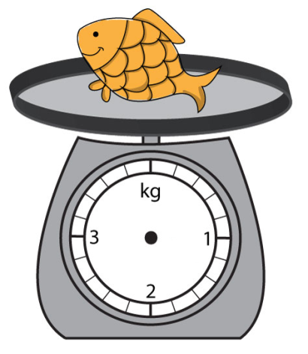

* 1. **30 × 2**
  2. **20 × 2**
  3. **20 × 3**

**$28.8 per kg**

* 1. **30 × 3**

1. Which of the following is the most suitable expression to estimate the value of $\text{17.78} \text{÷} \text{5}\text{.76}+3.2$?
   1. **17 ÷ 6 + 3**
   2. **17 ÷ 5 + 4**
   3. **18 ÷ 6 + 3**
   4. **18 ÷ 5 + 4**
2. Which of the following is the most suitable expression to estimate the value of $\text{6.03} \text{×}\text{ 2.9} -\text{12}\text{.1}$?
   1. **6 × 3 – 12**
   2. **6 × 4 – 12**
   3. **7 × 3 – 12**
   4. **7 × 4 – 12**
3. 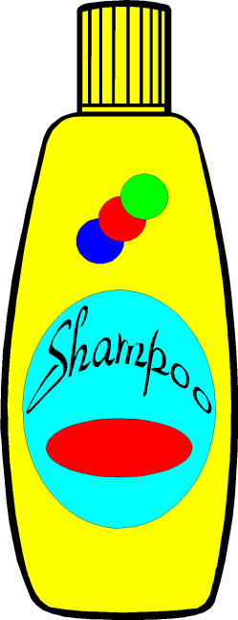The price of a bottle of shampoo is $24.8. Keith has $199. He buys 4 bottles of shampoo. Which of the following is the most suitable expression to estimate the money remained?
   1. **100 – 24 × 4**
   2. **100 – 25 × 4**
   3. **200 – 24 × 4**
   4. **200 – 25 × 4**
4. There is $138.6 in Cindy’s stored value card. She takes the MTR and goes shopping in a supermarket with this card by spending $19.5 and $51.8 respectively. Which of the following is the most suitable expression to estimate the balance of Cindy’s stored value card?

e

**A. 140 – 20 – 50 B. 140 – 10 – 50**

**C. 130 – 20 – 50 D. 130 – 10 – 50**

──　End　──

**Answers**

|  |  |  |  |  |  |  |  |  |
| --- | --- | --- | --- | --- | --- | --- | --- | --- |
| 1 | 2 | 3 | 4 | 5 | 6 | 7 | 8 | 9 |
| D | **B** | **D** | **B** | **D** | **C** | **A** | **D** | **A** |