**Learning Unit：Angles related with Lines and Rectilinear Figures  
Distinguish among corresponding angles, alternate angles and interior angles on the same side of the transversal**

J.

I.

H.

F.

E.

D.

Name: ( ) Class: Date:

1. Distinguish the following angles and write down the letters in the space provided.

B.

A.

C.

|  |  |  |
| --- | --- | --- |
| D. | E. | F. |
|  |  | I.  H.  G. |
|  |  |  |

Corresponding angles:

Alternate angles:

Interior angles on the same side of the transversal:

1. Look at the following figures and answer the questions.
2. Pair up the angles and write down the letters in the space provided.

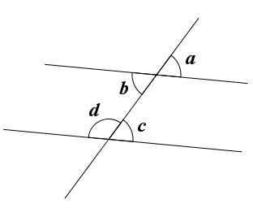

Corresponding angles: ____and____

Alternate angles: ____and____

Interior angles on the same side of the transversal: ____and____

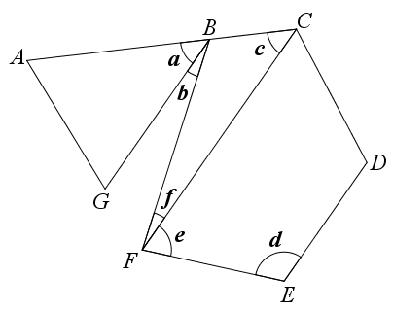2. In the following figure, *ABC* is a straight line. Draw lines to match the angles with their categories and write down the transversal.

|  |  |  |  |
| --- | --- | --- | --- |
| *d* and *e* |  |  | are a pair of corresponding angles and the transversal is __________. |
| *a* and *c* |  |  | are a pair of alternate angles and the transversal is __________. |
| *b* and *f* |  |  | are a pair of interior angles on the same side of the transversal and the transversal is __________. |

**Answer**

**Learning Unit：Angles related with Lines and Rectilinear Figures  
Distinguish among corresponding angles, alternate angles and interior angles on the same side of the transversal**

J.

I.

H.

F.

E.

D.

Name: ( ) Class: Date:

1. Distinguish the following angles and write down the letters in the space provided.

B.

A.

C.

|  |  |  |
| --- | --- | --- |
| D.  E. | F. |  |
|  |  | I.  H.  G. |
|  |  |  |

Corresponding angles: C, E

Alternate angles: F, G

Interior angles on the same side of the transversal: B, D

1. Look at the following figures and answer the questions.
2. Pair up the angles and write down the letters in the space provided.



Corresponding angles: *a* and *c*

Alternate angles: *b* and *c*

Interior angles on the same side of the transversal: *b* and *d*

2. In the following figure, *ABC* is a straight line. Draw lines to match the angles with their categories and write down the transversal.



|  |  |  |  |
| --- | --- | --- | --- |
| *d* and *e* |  |  | are a pair of corresponding angles and the transversal is  *AC* . |
| *a* and *c* |  |  | are a pair of alternate angles and the transversal is  *BF* . |
| *b* and *f* |  |  | are a pair of interior angles on the same side of the transversal and the transversal is  *FE* . |