**Learning Unit：Angles related with Lines and Rectilinear Figures**

J.

I.

H.

F.

E.

D.

**Distinguish between the interior angles and exterior angles of a polygon**

Name: ( ) Class: Date:

1. Distinguish the interior angles and exterior angles of the following polygons. Colour the interior angles in red and exterior angles in blue.

|  |  |
| --- | --- |
| 1. | 2. |
| 3. | 4. |
| 5. | 6. |

B. Distinguish the interior angles and exterior angles of the following concave polygon. Write down the letters for the answers.

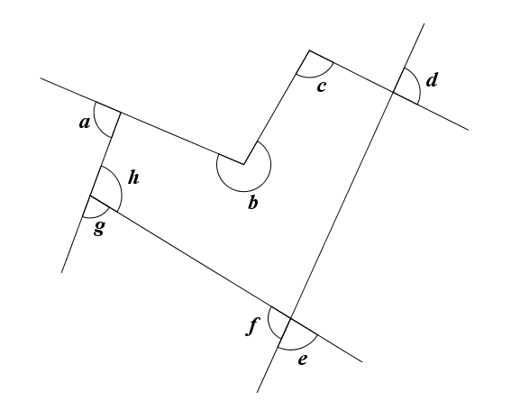

Interior angles:

Exterior angles:

**Answer**

**Learning Unit：Angles related with Lines and Rectilinear Figures**

J.

I.

H.

F.

E.

D.

**Distinguish between the interior angles and exterior angles of a polygon**

Name: ( ) Class: Date:

1. Distinguish the interior angles and exterior angles of the following polygons. Colour the interior angles in red and exterior angles in blue.

|  |  |
| --- | --- |
| 1. | 2. |
| 3. | 4. |
| 5. | 6. |

B. Distinguish the interior angles and exterior angles of the following concave polygon. Write down the letters for the answers.



Interior angles: *b, c, h*

Exterior angles: *a, f, g*