**Learning Unit：Angles related with Lines and Rectilinear Figures  
Properties of angles related with parallel lines (2)**

J.

I.

H.

F.

E.

D.

Name: ( ) Class: Date:

Answer the following questions. (All working must be clearly shown.)

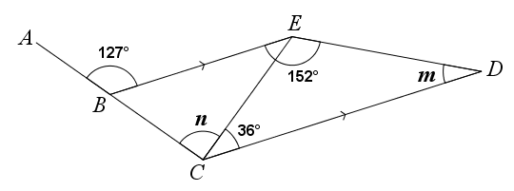1.

In the above figure, *ABC* is a straight line. *BE* // *CD* and ∠*BED* = 152°.

Find *m* and *n*.

|  |
| --- |
|  |

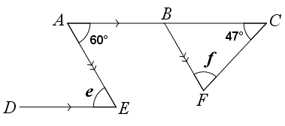2.

In the above figure, *ABC* is a straight line. *AC* // *DE* and *AE* // *BF*. Find *e* and *f*.

|  |
| --- |
|  |

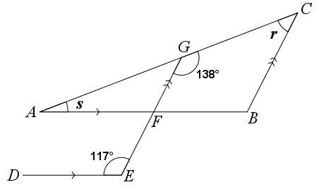3.

In the above figure, *AGC*, *AFB* and *EFG* are straight lines. *AB* // *DE* and *BC* // *EG*.

Find *r* and *s*.

|  |
| --- |
|  |

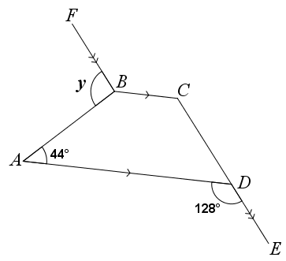4.

In the above figure, *CDE* is a straight line. *BC* // *AD* and *FB* // *CE*. Find *y*.

|  |
| --- |
|  |

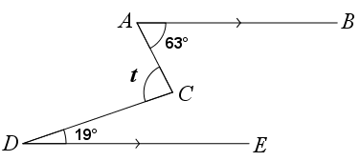5.

In the above figure, *AB* // *DE*. Find *t*.

|  |
| --- |
|  |

**Answer**

**Learning Unit：Angles related with Lines and Rectilinear Figures  
Properties of angles related with parallel lines (2)**

J.

I.

H.

F.

E.

D.

Name: ( ) Class: Date:

Answer the following questions. (All working must be clearly shown.)

1.

In the above figure, *ABC* is a straight line. *BE* // *CD* and ∠*BED* = 152°.

Find *m* and *n*.

*EDC* +*BED* = 180° (int.∠s, *BE* // *CD*)

*m* + 152° = 180°

*m* = 28°

*BCD* = *ABE* (corr.∠s, *BE* // *CD*)

*n* + 36° = 127°

*n* = 91°

2.

In the above figure, *ABC* is a straight line. *AC* // *DE* and *AE* // *BF*. Find *e* and *f*.

*AED* = *BAE* (alt.∠s, *AC* // *DE*)

*e* = 60°

*CBF* = *BAE* (corr.∠s, *AE* // *BF*)

= 60°

*BFC* +*FCB* +*CBF* = 180° (∠ sum of △)

*f* + 47°+ 60° = 180°

*f* + 107° = 180°

*f* = 73°

3.

In the above figure, *AGC*, *AFB* and *EFG* are straight lines. *AB* // *DE* and *BC* // *EG*.

Find *r* and *s*.

*GCB* +*CGF* = 180° (int.∠s, *BC* // *EG*)

*r* + 138° = 180°

*r* = 42°

*AFG* = *DEF* (corr.∠s, *AB* // *DE*)

= 117°

*AGF* = *GCB* (corr.∠s, *BC* // *EG*)

*AGF* = *r*

= 42°

*GAF* +*AFG*+*AGF* = 180° (∠ sum of △)

*s* + 117°+ 42° = 180°

*s* + 159° = 180°

*s* = 21°

4.

In the above figure, *CDE* is a straight line. *BC* // *AD* and *FB* // *CE*. Find *y*.

*BCD* =*ADE* (corr.∠s, *BC* // *AD*)

= 128°

*FBC* = *BCD* (alt.∠s, *FB* // *CE*)

= 128°

*ABC* +*DAB* = 180° (int.∠s, *BC* // *AD*)

*ABC* + 44° = 180°

*ABC* = 136°

*FBA* +*ABC*+*FBC* = 360° (∠s at a pt.)

*y* + 136°+ 128°= 360°

*y* + 264° = 360°

*y* = 96°

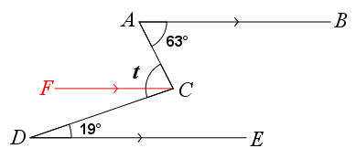5.

In the above figure, *AB* // *DE*. Find *t*.

Construct *FC* such that *FC*, *AB* and *DE* are parallel lines.

*ACF* = *BAC* (alt.∠s, *FC* // *AB*)

= 63°

*FCD* = *CDE* (alt.∠s, *FC* // *DE*)

= 19°

*ACD* = *ACF* +*FCD*

*t* = 63°+ 19°

*t* = 82°